Predictive Analytics for Customer Purchase Behaviour in E-commerce
Gorasiya Vivekkumar Kishorbhai

Dissertation submitted to the International Business School for the partial fulfilment of the requirement for the degree of MASTER OF SCIENCE IN IT FOR BUSINESS DATA ANALYTICS.
December 2025

DECLARATION
I​‍​‌‍​‍‌​‍​‌‍​‍‌ hereby declare that my Business Data Analytics Project is solely my personal research, and I have not submitted it, either partially or fully, for any other degree or academic award at this or any other institution. I have acknowledged and referenced all the information sources that I have used in this project as per the Harvard referencing system.
I assure that this project is free from plagiarized content and does not comprise any previously published material or work of any other person, except where permission has been granted. Further, I agree to the University's use of my dissertation without limitations, including online reproduction, electronic distribution, and adaptation for teaching and educational purposes, of any whole or part of this ​‍​‌‍​‍‌​‍​‌‍​‍‌work.

Signature -

Gorasiya Vivekkumar Kishorbhai.

ACKNOWLEDGEMENTS
I​‍​‌‍​‍‌​‍​‌‍​‍‌ am truly thankful to my supervisors for their constant direction, helpful suggestions, and educational support during the realization of this Business Data Analytics Project. Without their knowledge and their insistence, it would have been very difficult to figure out the analytical approach and to raise the overall level of this work.
I also owe a debt of gratitude to the faculty of the MSc in IT for Business Data Analytics program, who have provided me with a solid academic foundation in both business and data analytics concepts, and therefore have enabled me to complete this project.
At the end, I wish to convey my thanks to the family and friends who have been a source of motivation and endurance during this academic ​‍​‌‍​‍‌​‍​‌‍​‍‌journey.

EXECUTIVE SUMMARY
This​‍​‌‍​‍‌​‍​‌‍​‍‌ business data analytics project is intended to exemplify the use of predictive analytics for the purpose of anticipating customer purchase behaviour in an online store with the help of 2024 sales transaction data. In​‍​‌‍​‍‌​‍​‌‍​‍‌ a world that is rapidly becoming digital, competition is very tough, and only the best survives, companies need data-driven insights to be able to target customers more efficiently, implement better retention strategies and make operational decisions. The focus of this research has been on the behavioural, demographic, and temporal factors affecting the likelihood of a purchase, and the generation of predictive models to facilitate the business decision-making process is the other goal of this work.
This project is a quantitative, data-driven one that heavily relies on predictive analytics and machine learning. An analytical data workflow including data preprocessing, exploratory data analysis (EDA), and feature engineering with Recency, Frequency, and Monetary (RFM) metrics creation was carried out. In Python, Logistic Regression, Decision Tree, and Random Forest were some of the models that were used. Classification metrics like accuracy, precision, recall, F1-score, and ROC–AUC were the criteria used for evaluating the performance of the models, and these measures were the means to ensure the models' robustness and comparability.
The solution was in using clustering to turn the raw transactional data into understandable features and customer segments and then using supervised learning models to predict customer purchase ​‍​‌‍​‍‌​‍​‌‍​‍‌behaviour. Among the models, the ensemble-based Random Forest model was the one that managed to beat all the others, thus indicating that it was the non-linear relationships and interaction effects between customer features that explained most of the model's performance. The investigation into the features' contribution to the model revealed that the recency of the purchase, the frequency of the purchase, and the total monetary value were the three most significant predictors of future purchasing ​‍​‌‍​‍‌​‍​‌‍​‍‌behaviour.
While​‍​‌‍​‍‌​‍​‌‍​‍‌ the analysis is somewhat successful in achieving its objectives, it fails to account for numerous detractors in the study. Firstly, the data used for the study was limited to only one year of the structurally organized outlet transactional data of a single store, and there was no consideration of any unstructured data, such as customer reviews or clickstream behaviour. Further research can incorporate multi-year data, real-time behavioural signals, and advanced deep learning algorithms not just to obtain higher predictive accuracies but also to be able to generalize ​‍​‌‍​‍‌​‍​‌‍​‍‌better.
On​‍​‌‍​‍‌​‍​‌‍​‍‌ the reflective side, I have enhanced my ability to mix business acumen with the application of sophisticated data analytics techniques through this venture. It was a great opportunity for me to implement the entire analytical workflows and to assess the models and, in addition, to deliver the technical results in the shape of actionable business insights. My initiative to work with others on data-driven projects has been elevated through this project and I have recalled that it is my obligation as a professional in the analytics field to manage the data ethically and communicate ​‍​‌‍​‍‌​‍​‌‍​‍‌‍‌‍‍‌‍‌‍‍‌clearly.

Table of Contents
CHAPTER 1 INTRODUCTION 6
1.1 Background and Context of the Project 6
1.2 Business and Technical Significance of the Chosen Problem 6
1.3​‍​‌‍​‍‌​‍​‌‍​‍‌ Clear Problem Statement and Objectives of the Project 7
1.4​‍​‌‍​‍‌​‍​‌‍​‍‌ Scope of the Study and Expected Contributions 8
CHAPTER 2 LITERATURE REVIEW 10
2.1​‍​‌‍​‍‌​‍​‌‍​‍‌ Overview of Theoretical Foundations, Frameworks, and Prior Studies Relevant to the Problem Domain 10
2.2​‍​‌‍​‍‌​‍​‌‍​‍‌ Discussion of Advanced Data Analytics Techniques Relevant to the Problem 11
2.3​‍​‌‍​‍‌​‍​‌‍​‍‌ Identification of Gaps in the Literature That the Project Addresses 13
CHAPTER 3: RESEARCH METHODOLOGY 15
3.1 Introduction to Research Methodology 15
3.2 Research Design 15
3.3 Data Source and Dataset Description 16
Importing the dataset 17
3.3.1 Key Data Attributes 17
3.4 Data Preprocessing 18
3.4.1 Data Cleaning 18
3.4.2 Data Transformation 19
Total sales 20
3.5 Feature Engineering 22
3.5.1 RFM Metrics 22
Purchase frequency 23
Step 9 - Frequency per user 23
3.5.2 Behavioural and Temporal Features 24
Product Performance 25
3.6 Predictive Modelling Techniques 27
3.6.1 Logistic Regression 27
3.6.2 Decision Tree Classifier 27
3.6.3 Ensemble Methods 27
3.7 Model Evaluation Metrics 27
3.8 Ethical Considerations 28
Chapter 4: EXPLORATORY DATA ANALYSIS (EDA) 28
Customer Purchase Patterns 29
CORRELATION ANALYSIS 30
K-Means Clustering (Customer Segmentation) 31
Cluster Profiling Table 35
Temporal Trends 36
CHAPTER 5: IMPLEMENTATION OF ALGORITHMS OF MODELS WITH RESULTS AND ANALYSIS 41
5.1 Introduction 41
5.2 Overview of Modelling Approach and Tools 41
5.3 Logistic Regression Model Implementation 42
Create RFM Feature 42
5.4 Decision Tree Classifier Implementation 45
5.4.1 Logistic Regression Results 45
Machine learning models 45
5.4.2 Decision Tree Results 46
5.4.3 Ensemble Model Results 47
5.5 Ensemble Learning Using Random Forest 49
5.6 Model Training Strategy 50
5.7 Model Evaluation Metrics and Performance Analysis 50
5.8 Model Optimization and Tuning 51
5.9 Interpretation and Business Relevance 51
Summary of Results and Analysis 51
CHAPTER 6: Business Insights, Recommendations & Conclusion 54
6.1 Discussion of Key Findings 54
6.2 Business Implications 54
6.3 Limitations of the Study 55
6.4 Recommendations for Future Research 56
6.5 Conclusion 56
Reference List 59
APPENDIX 67
Appendix A: GitHub Repository 67

LIST OF FIGURES
Figure 1: Successfully loaded the dataset 15
Figure 2: Step 1- Cleaning data 17
Figure 3: Step 2 - Converting time stamp to datetime 17
Figure 4: Step 3 - Filter only "Purchase" interactions 17
Figure 5: Code for total sales 18
Figure 6: Step 5 - Sales by Date 18
Figure 7: Step 6 - Sales by Product 19
Figure 8: Step 7 - Sales by User 19
Figure 9: Step 8 - Daily Sales Trend Plot 19
Figure 10: Daily Sales trend graph 20
Figure 11: Step 9 - Frequency per user 21
Figure 12: Step 10 - Plot Top 10 Frequent Buyers 21
Figure 13: Top 10 Users by Purchase Frequency Graph 22
Figure 14: Step 11: Statistical data of purchases per user 22
Figure 15: Step 12 Product popularity performance 23
Figure 16: Step 13: Plot top 10 Products 23
Figure 17: Top 10 Products by Purchase Count 24
Figure 18: Code for Statistical Performance 25
Figure 19: Step 15 - Loading all 3 datasets 26
Figure 20: Step 16 - Cleaning the column names 26
Figure 21: Step 17- Merge datasets 27
Figure 22: Merged datasets 27
Figure 23: Output after merging both datasets 27
Figure 24: Step 18- Defining correlation features 28
Figure 25: Step 19 - Code for Correlation Matrix 28
Figure 26: Correlation Matrix graph showing Demographic, frequency, and purchase 29
Figure 27: Step 20 - K Clustering (Customer Segmentation) 29
Figure 28: Step 21: Code and Output frequency of purchase and purchase amount 30
Figure 29: Step 22 - cluster data 30
Figure 30: Step 23 - Customer Segmentation 31
Figure 31: Customer Segmentation by Age Vs Purchase Amount 31
Figure 32: Code for Cluster data for frequency data and purchase amount 32
Figure 33: Step 24 – Code for Customer Segmentation Based on Frequency & Spending 33
Figure 34: Customer Segmentation Based on Frequency & Spending Graph 33
Figure 35: Step 25 Code for Cluster Profile 34
Figure 36: Output for cluster profile 34
Figure 37: Step 26 - Importing libraries 35
Figure 38: Step 27 - File detection/loading csv 36
Figure 39: Step 28 - Quick peek code 37
Figure 40: Output for Transaction sample 37
Figure 41: Output for customer sample 37
Figure 42: Output for product 38
Figure 43:Step 29 - Code for Merge cut-off date per user 40
Figure 44: Step 30 - Code for Pre-cutoff transactions, Frequency, monetary and Recency 41
Figure 45: Output for Pre-cutoff transactions, Frequency, monetary and Recency 41
Figure 46:Step – 31 Code for Post-cutoff data and create label 41
Figure 47: Output of Post-cutoff data and create a label 42
Figure 48: Step 32 - code for train_test1_split 44
Figure 49: Step 33 - code for train model 45
Figure 50: Output of train label and test label 45
Figure 51: Code for Tree models 45
Figure 52: Step 34 - Code for importing matrix 46
Figure 53: Output of Decision Tree Model 46
Figure 54: Step 35 Code and Output for Random Forest 47

CHAPTER 1 INTRODUCTION

1.1 Background and Context of the Project
Many factors, such as advanced technologies, increased access to the internet, the usage of smartphones by everybody, and the expansion of digital retail platforms. Over​‍​‌‍​‍‌​‍​‌‍​‍‌ the last several years, e-commerce has been growing rapidly, mainly attributed to numerous factors like advanced technologies (Bădîrcea et al., 2021), wider internet access, the widespread use of smartphones, and the expansion of digital retail platforms. In the meantime, businesses have been able to collect a massive amount of behavioural data through their interactions with customers as more people choose online purchasing. Such data are inclusive of online searching, purchase history, product preferences, demographic attributes, and time-based patterns that mirror how customers move in digital environments and make their buying decisions.
However, organizations must employ data scientists who can closely examine customer data and find the insights because they are quite aware that the data is huge, complex, and multi-dimensional in nature. Companies that use conventional analytical methods may not understand nonlinear relationships as well as subtle behavioural patterns in large datasets. That is why companies cannot find out what would make customers buy, who will most likely buy again, and which products will be needed in the future. The problem of being limited to the most difficult side in the case of highly competitive online markets, where customer retention, targeted marketing, and efficient operational planning are the most valuable ​‍​‌‍​‍‌​‍​‌‍​‍‌things.

1.2 Business and Technical Significance of the Chosen Problem
Knowing​‍​‌‍​‍‌​‍​‌‍​‍‌ customers' purchase behaviour through predictive analytics is very critical to a business (Gupta, Rao, and Pandey, 2024). It is important because it shows how a company will use the information to attract new customers, keep old ones, and convert casual shoppers into loyal customers. In​‍​‌‍​‍‌​‍​‌‍​‍‌ a highly competitive internet-based markets, the power to foresee the purchasing habits of buyers is what chiefly provides a difference in creating personalized advertising campaigns that differentially appeal various groups of customers. Simply saying, if companies can forecast the exact products that their customers will buy, then they will be able to promote products more effectively, suggest products that might be interesting, create more communication channels between the company and customers which, in fact, will result in more customer interaction.

Indeed, such customer interaction is one of the factors that contribute to customer satisfaction and loyalty which, in turn, are very important pillars of customer retention and long-term revenue streams. In addition, by buying so accurately a firm can substantially elevate the total performance of its marketing activities as the budget will be expended on those customers who are most likely to be converted, thus resulting in higher ROI.
Additionally, marketing innovation can also benefit from predictive customer insights, while other departments, such as inventory management and supply chain coordination, can take advantage of the same insights to improve their performance and expedite their processes (Pasupuleti et al., 2024).
Accurate demand forecasting gives businesses the option of stocking the right quantities and thus, it avoids both stockouts that cause lost sales and overstocking that not only ties up financial resources but also raises storage costs. Corporations that adeptly control their inventories through data-driven insights are positioning themselves ahead of the competition by having the capability of rapidly satisfying customer demand and, at the same time, ensuring that operations are going smoothly and ​‍​‌‍​‍‌​‍​‌‍​‍‌efficiently.
Technically speaking, the topic addressed here is just as important as the difficulty in dealing with huge and diverse data collections that contain demographic characteristics, browsing behaviour, purchase histories, and time-related features. Solving this problem demands a variety of advanced analytical skills, for instance, feature extraction, dealing with missing or unbalanced data, and applying machine learning algorithms that can identify nonlinear interactions.

1.3​‍​‌‍​‍‌​‍​‌‍​‍‌ Clear Problem Statement and Objectives of the Project
Many e-commerce businesses that have access to detailed customer data still fail to accurately forecast which customers will make future purchases and what factors will influence these behaviours (Madanchian, 2024). The consequences of such forecasting inefficiency are: mistargeting, lower marketing ROI, and customer retention results. The main issue, which this project is about, reads as follows:
In what way can predictive analytics help to forecast customer purchase behaviour in e-commerce based on 2024 sales data, and which variables show the purchase likelihood the most?
With a view to solving this problem, the project sets out the following objectives:
- Carry out exploratory data analysis to find patterns, trends, and behavioural relationships in the 2024 e-commerce dataset.
- Generate the required features, e.g., Recency, Frequency, and Monetary (RFM) metrics to represent behavioural tendencies (Rajendran, 2025)
- Create predictive models with the help of algorithm examples like logistic regression, decision trees, and ensemble methods.
- Evaluate the performance of the models using appropriate metrics (e.g., accuracy, ROC-AUC, precision, ​‍​‌‍​‍‌​‍​‌‍​‍‌recall).
- By means of model interpretation, find out which are the strongest predictors of purchase behaviour.
- Communicate the results of analytics in the form of feasible business recommendations that can facilitate decision-making in marketing, retention, and inventory ​‍​‌‍​‍‌​‍​‌‍​‍‌planning.

1.4​‍​‌‍​‍‌​‍​‌‍​‍‌ Scope of the Study and Expected Contributions
This research will only focus on the structured transactional data that was generated in the year 2024. Sach data main includes demographic variables; purchase history is product categories and temporal indicators. The dissertation/ papers will only deal with predictive modelling of purchase likelihood and will not until other applications such as recommendation engines, sentiment analysis, or real-time dynamic personalization. Besides that, customer reviews and social media content have not been considered, nor has any email-based data.
The​‍​‌‍​‍‌​‍​‌‍​‍‌ project, therefore, pledges to serve as a vehicle through which the measures can go beyond merely providing data to achieving strategic business value. It can be regarded as an instance of the role of predictive analytics in current e-commerce scenarios.
The project, thus, is committed to being a means for the measures to move beyond the simple provision of data towards the achievement of strategic business value. It may be viewed as an illustration of the role of predictive analytics in the present-day e-commerce scenarios.
The project is, therefore, committed to being a means for the measures to move beyond the simple provision of data towards the achievement of strategic business value. It may be seen as an example of the role of predictive analytics in the present-day e-commerce scenarios.
The project, thus, is committed to being a vehicle through which the measures can go beyond the mere provision of data to the achievement of strategic business value. It can be seen as an example of the role of predictive analytics in the present-day e-commerce scenarios.
In a nutshell, the problem of modelling customer purchase behaviour is addressed through a detailed review of concepts, theories, and studies.
The paper provides a review of concepts, theories, and studies as a basis for modelling customer purchase behaviour. The paper provides a conceptual, theoretical, and empirical basis for the modelling of customer purchase behaviour.

CHAPTER 2 LITERATURE REVIEW

2.1​‍​‌‍​‍‌​‍​‌‍​‍‌ Overview of Theoretical Foundations, Frameworks, and Prior Studies Relevant to the Problem Domain
-commerce analysis of consumer purchase behaviour founded on varied theories and concepts has been the chief focus of numerous research works (Yang, Xu, and Xing, 2022). The study of customer behaviour indicates that buying is mostly influenced by three types of factors: cognitive, emotional, and situational, which in their turn drastically affect the manner of a person's information processing, alternative choosing, and finally purchasing or not deciding. Now all these decisions are executed in cyberspace, but at the same time, the data are real-time and quite substantial in terms of behavioural trials such as browsing, searching activity, product clicks, and order histories that are available through online interaction.
Many research works have focused their attention on the analysis of customer purchase behaviour in e-commerce based on different theories and concepts (Yang, Xu, and Xing, 2022). The study of customer behaviour reveals that buying is largely determined by three types of factors: cognitive, emotional, and situational, which eventually have a great impact on the ways in which a person processes the information, makes a choice from the available alternatives, and finally decides whether to purchase or not. Presently, these decisions are being made in the virtual world, but the data, on the other hand, are real-time and quite significant in terms of behavioural trials such as browsing, searching activity, product clicks, and order histories that are accessible through online interaction.
The customer decision-making journey is just one of the examples that has helped to understand the steps that consumers take in the digital world and likewise acknowledge the stages of awareness, consideration, evaluation, purchase, and post-purchase engagement. These frameworks
are the steps of customer experience through the use of various communication channels like web portals, mobile apps, email campaigns, and targeted ​‍​‌‍​‍‌​‍​‌‍​‍‌​‍​‌‍​‍‌​‍​‌‍​‍‌advertisements
.
The RFM (Recency–Frequency–Monetary) model is yet another extensively used framework in the field of repeat purchasing behavioural analysis (Anitha and Patil, 2022), which segments customers according to when they made a purchase, how often they buy, and how much they spend. As RFM indicators are directly related to behavioural engagement and cash inflow, they are very commonly used in tasks such as segmentation, churn prediction, and purchase forecasting.
Conversely, variables that determine past buying activities, such as previous purchase history, frequency of visits, product preferences, and time-of-day activity, were found to be great predictors of future buying in an e-commerce analytics study. Besides, researchers have tried to find out how promotional events, discounts, and personalised recommendations can attract buyers to perform a transaction. Also, demographic characteristics like age, location, and purchasing power have been linked to different patterns of shopping engagement and conversion rates.
These​‍​‌‍​‍‌​‍​‌‍​‍‌ temporal patterns have also been clearly documented in the literature. Consumer behaviour is predominantly seasonal and, thus, can change depending on whether it is a holiday or a big sale event. These temporal fluctuations emphasize the use of time-related features when predicting the probability of a ​‍​‌‍​‍‌​‍​‌‍​‍‌purchase. Therefore, both theoretical and empirical studies in e-commerce customer behaviour highlight the role of psychological processes, behavioural interactions, demographic characteristics, and contextual factors in shaping purchase behaviour (Chen, Lan, and Chang, 2023). The predictive analytics frameworks leverage these insights to develop models that can forecast customer behaviours based on the raw ​‍​‌‍​‍‌​‍​‌‍​‍‌data.

2.2​‍​‌‍​‍‌​‍​‌‍​‍‌ Discussion of Advanced Data Analytics Techniques Relevant to the Problem
Identifying​‍​‌‍​‍‌​‍​‌‍​‍‌ how customers make their purchases can only be done by using analytical methods that can find complex relationships in large and multidimensional datasets. Therefore, advanced data analytics and machine learning techniques are the necessary instruments that any company can use to discover the patterns that are not visible by conventional statistical methods.
Logistic regression is the technique that is used most often for solving problems of binary classification, such as the prediction of purchase versus non-purchase (Sudirman et al., 2024). Although it is a transparent model and quite simple to perform, logistic regression keeps its position when it comes to the assumption of linear relationships and may fail to identify more complicated behavioural dynamics without thorough feature ​‍​‌‍​‍‌​‍​‌‍​‍‌engineering.
By their very nature, decision trees are a rule-based system that not only can be easily understood but also provides a way of outlining crucial decision paths. Tree-based algorithms classify customers according to conditions such as the level of their spending or recency.
With the help of random forests, the predictive power of a model can be heightened by the creation of several trees, and then the results are averaged. Such a step leads to a decrease in variance and results in better generalization. Besides that, random forests, as a matter of their nature, let the importance of features be ranked; thereby, they also indicate variables that have deep predictive power.
For example, gradient boosting decision tree ensembles sequentially improve models by concentrating on the errors made by the previous steps. The said techniques are characterized by the high predictive power, particularly in cases of complex, non-linear relationships. Due to their ability to discover subtle data patterns and interactions, boosting methods are mainly referred to as customer behaviour prediction tools.
Support‍‌‍‍‌‍‌‍‍‌ vector machines (SVMs) are very good at handling data with a lot of dimensions, and they use kernel functions to separate classes in non-linear environments (K Saravanan et al., 2023). Since they consume a lot of computational power, SVMs should only be taken into consideration as a last resort when other methods have not yielded results, and the decision boundaries need to be extremely accurate.
Neural networks and deep learning architectures basically open the scope of the study by making it possible to identify very complex nonlinear patterns. Generally, neural networks are associated with image and text data; however, they can also be implemented for tabular data, particularly when the feature interactions are complex. The major factor limiting their use to be more widespread is their interpretability issue, which can be quite challenging in business environments that require transparent ​‍​‌‍​‍‌​‍​‌‍​‍‌reasoning.
Besides supervised methods, unsupervised ones, such as clustering, are also very important in that they help the company know the customers better by creating a profile based on their shared traits. Methods such as K-Means and hierarchical clustering assign individuals to groups that characterize their purchasing habits, value segments, or engagement levels (LING and WEILING, 2025). These groups can then be fed into predictive models as additional features.
Advanced‍‌‍‍‌‍‌‍‍‌ analytics feature engineering is largely about getting more insightful predictors from raw data. As an example, the most utilized engineered features are the RFM metrics, time-since-last-purchase, category-level preferences, cart abandonment, session length, and browsing frequency. Feature extraction from a time series - for instance, differentiating weekdays from weekends, or identifying seasonal cycles - can be a very effective method of model enrichment through the capturing of time-dependent behaviour.
Moreover, the measures, ROC-AUC, precision, recall, and confusion matrices, indicate if the created model is ready for real-world testing with a high degree of confidence (Sathyanarayanan and Roopashri Tantri, 2024).
When these steps are taken, data analytics and machine learning become the instruments for the creation of strong, clear, and operational predictive frameworks capable of making trustworthy forecasts of customer purchase ​‍​‌‍​‍‌​‍​‌‍​‍‌‍‌‍‍‌‍‌‍‍‌behaviour.

2.3​‍​‌‍​‍‌​‍​‌‍​‍‌ Identification of Gaps in the Literature That the Project Addresses
While past research has considerably deepened the understanding of consumer behaviour and the use of predictive models in e-commerce, there are still quite a few loopholes that have not been addressed.
Firstly,​‍​‌‍​‍‌​‍​‌‍​‍‌ many of the research works that have been published are largely dependent on small or specific domain datasets. This, in effect, limits the extent to which the results can be generalized. The truth of the matter with online shopping is that it is extremely diverse, and shoppers can do all sorts of things, such as shopping in different product categories, targeting different demographic segments, and time periods. Hence, a 2024 sales dataset that is comprehensive and sufficiently large can be utilized to bridge this gap (Ahaggach, Abrouk, and Lebon, 2024).
Secondly, the previous studies that have been done tend to concentrate only on one feature at a time, for example, demographic, behavioural, or temporal, and do not consider the interaction between the features. No one factor is likely to influence a person's purchasing behaviour. It is rather a combination of factors than one single factor.
Third, hardly any research works have examined the comparative performance of various machine learning algorithms by comparing them under similar conditions (Asif et al., 2021). Most papers have placed their emphasis on a single method; hence, it is not clear which model will yield the best results in terms of purchase prediction. This research settles this question by comparing different models (e.g., logistic regression, decision trees, and ensemble methods) with the aid of standardized performance metrics to determine which approach is the most effective.
Fourth, most​‍​‌‍​‍‌​‍​‌‍​‍‌ importantly, in most of the sophisticated models, there is a trade-off between the precision and the capacity to relate the technical outputs to the business implications. However, this aspect is almost entirely neglected by most papers. Consequently, the insights derived from predictive models might not be very helpful in formulating marketing strategies, planning customer retention, or managing inventory. By bridging this gap through linking data analytics outcomes to data-driven business decisions, this project thereby increases the practical ‍‌‍‍‌‍‌‍‍‌value.
At last, it could be some researchers who knowingly ignore the interpretability of their model, which is a very significant factor in the business area where the decision-making needs reasonable accounts and not just the prediction (Hassija et al., 2023). This paper implements machine learning methods like feature importance analysis to clarify the process and to deliver viable insights.
The project is moving beyond the surface of these issues, not only grasping them but also discovering the means to resolve them, and offers a more complete, realistic, and methodologically sound understanding of customer purchase production in e-commerce.

CHAPTER 3: RESEARCH METHODOLOGY

3.1 Introduction to Research Methodology
The​‍​‌‍​‍‌​​‍​‌‍​‍‌​‍​‌‍​‍‌ methodology chapter elaborates on the research methods used to investigate consumer purchasing behaviour in the e-commerce sector via predictive analytics linked to sales data from 2024 (Bernard and Ampart, 2025). A methodology is comparable to a compass that guides the research journey from data gathering, to data cleaning, data analysis, predictive modelling, and finally, reporting the results. In an analytical research, having a clearly defined methodology is actually the most crucial factor as it significantly determines the validity, reliability, transparency, and reproducibility of the results.
Today, companies operating within the e-commerce sector are constantly filling their databases with consumer data generated by online transactions, browsing behaviour, and digital interactions. Nevertheless, the mere possession of large datasets does not necessarily lead to valuable insights. Only by selecting the right analytical methods and rigorously following a methodological framework can raw data be turned into valuable knowledge that can be used for decision-making (Konstas et al., 2023). Therefore, this methodology was developed with the complexity of customer behavioural data in mind in order to be able to predict purchase behaviour correctly.
Given that the research problem is data-driven, a quantitative research methodology based on data analytics and machine learning techniques has been utilized. Quantitative methods are especially appropriate for predictive analytics as they provide for the objective measurement of the relationships between variables, statistical confirmation of the results, and the systematic assessment of the model's performance (Strielkowski et al., 2023). This book section is devoted to elaborating the research design, data sources, data preprocessing methods, feature extraction activities, predictive modelling methods, evaluation metrics, and ethical issues in customer data handling. The study by sequentially implementing each methodological step not only guarantees methodological rigor but also creates a space for future research in the field of e-commerce analytics.

3.2 Research Design
This research employs a quantitative, explanatory research design to investigate and clarify, with the help of statistical and machine learning models, the patterns of customer purchase behaviour as reflected by the numerical data. The main purpose of explanatory research is the discovery of causal or associative relationships between independent variables such as customer behaviour and transaction history and a dependent variable, i.e., the likelihood of purchase (Gerlich, 2023). By doing so, this approach goes beyond simply describing the data and tries to find the causes of the emergence of the patterns as well as their influence on purchasing ​‍​‌‍​‍‌​‍​‌‍​‍‌​‍​‌‍​‍‌​‍​‌‍​‍‌outcomes.
Quantitative research methods have been using in this case, along with predictive analytics, in which they support the testing of hypotheses, statistical modelling, and the comparison of the performance of various algorithms (Marko Sarstedt et al., 2024). Here, numerical variables from transactional and behavioural data are analysed to make purchase probability estimations. The incorporation of several machine learning models thus facilitates the strengthening of the research design through the possibility of comparative analysis and the confirmation of results from different modelling ​‍​‌‍​‍‌​‍​‌‍​‍‌approaches.
The​‍​‌‍​‍‌​‍​‌‍​‍‌ study uses a cross-sectional design to analyse transactional data that was collected throughout the calendar year 2024. A cross-sectional analysis gives an overview of customer behaviour in a specified time frame, thus enabling the detection of purchasing trends, behavioural patterns, and seasonal effects (Valendin et al., 2022). Such a design is appropriate for this study as it corresponds to the data set scope and the research objectives. Although longitudinal designs provide understanding of behavioural changes over the long term, a cross-sectional approach can adequately serve the purpose of looking into purchase behaviour and model performance within one year of e-commerce ​‍​‌‍​‍‌​‍​‌‍​‍‌activity.

3.3 Data Source and Dataset Description
The​‍​‌‍​‍‌​‍​‌‍​‍‌ dataset that underpins the study is a compilation of structured e-commerce transactional data based on the sales records of the year 2024. The data depicts the customer's journey through digital platforms, i.e., the completed transactions and the corresponding behavioural changes (Theodorakopoulos and Theodoropoulou, 2024). Structured transactional datasets are generally the most favourable in predictive analytics because of their standardization, consistency, and ease of machine learning method application.
The dataset accurately reflects e-commerce situations in the real world, where customers interact with online platforms by viewing products, selecting items, and making purchases (Esmeli and Gokce, 2025). Such interactions result in the generation of detailed data points that reveal customer preferences, engagement levels, and purchasing habits. Utilizing the dataset for an entire year is a way of making sure that the analysis takes into account the behaviour changes across different seasons, promotional periods, and market ​‍​‌‍​‍‌​‍​‌‍​‍‌conditions.

Importing the dataset
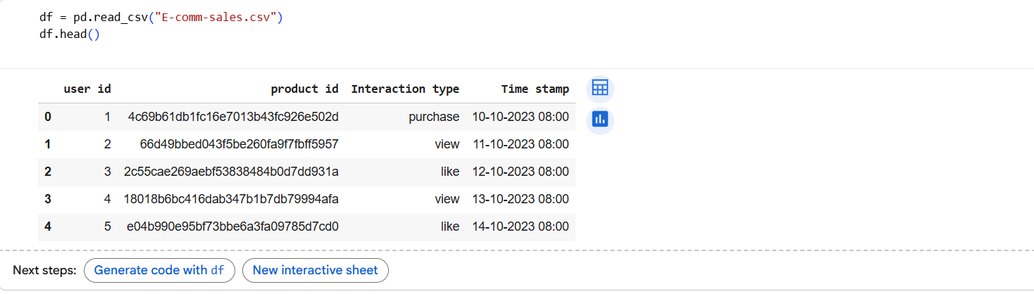
Figure 1: Successfully loaded the dataset

3.3.1 Key Data Attributes
The dataset includes several categories of variables, each representing a different dimension of customer behaviour:
Customer Demographics: Demographic variables are age group, gender, geographic region, and account tenure (Fisher, Lewin and Pilgeram, 2022). These characteristics give background information to the customers and facilitate the division of the market based on the socio-demographic features of the customers. Demographic data are instrumental in revealing the differences in purchasing behaviour that exist among various customer groups.
Transactional Variables: Transactional features are order ID, product category, purchase amount, number of items per order, and transaction date (Handojo et al., 2023). These variables are at the heart of the revenue and sales analysis and are, in fact, the primary representations of customer purchasing ​‍​‌‍​‍‌​‍​‌‍​‍‌activity.
Behavioural Variables: Behavioural indicators are those that show the number of times a customer has made a purchase, how long ago the last purchase was, total spending, and session-based activity metrics (Esmeli, Bader-El-Den and Abdullahi, 2020). These variables reflect the level of customer engagement and loyalty, which, in turn, are essential indicators of future purchase behaviour.
Temporal Variables: Temporal attributes are day of the week, month, season, and time since last purchase (Sokolova, 2022). Time-related variables reveal the effects of cycles and seasons that influence customers' purchasing decisions.
The target variable for predictive modelling is a binary purchase indicator, which indicates whether a customer purchased within a specified future time window. This binary classification approach is highly compatible with predictive analytics tasks in e-commerce ​‍​‌‍​‍‌​‍​‌‍​‍‌environments.

3.4 Data Preprocessing
Usually,​‍​‌‍​‍‌​‍​‌‍​‍‌ e-commerce data on the most basic level is full of inconsistencies of different kinds, entries that are missing, noise, and even extreme values that could have been caused by system errors, customer profiling that is not complete, or user behaviour that is not regular. If these issues are not taken care of, they can decrease the models' accuracy and trustworthiness. For this reason, the data preprocessing phase is very significant in the research ​‍​‌‍​‍‌​‍​‌‍​‍‌method.

3.4.1 Data Cleaning
Multiple data cleaning operations were conducted to elevate the data quality:
- Removal of duplicate transaction records: Duplicate records were located and removed so as not to count twice and thereby to have an unbiased model training (Do, Graefe and Naughton, 2022).
- Handling missing values: Missing demographic values were filled in through statistical imputation methods, such as mean or mode imputation, depending on whether the variable was numerical or categorical.
- Correction of inconsistent categorical labels: Differences in the naming conventions of categorical variables were changed to standard ones to make them consistent (McMurray, 2022).
- Outlier detection and removal: Extreme values of purchase amount were found by interquartile range (IQR) analysis and removed to have less distortion in model parameters (Khan et al., 2025).
These cleaning steps ensured that the dataset was accurate, consistent, and suitable for predictive modelling.
STEP 1 - Clean column names
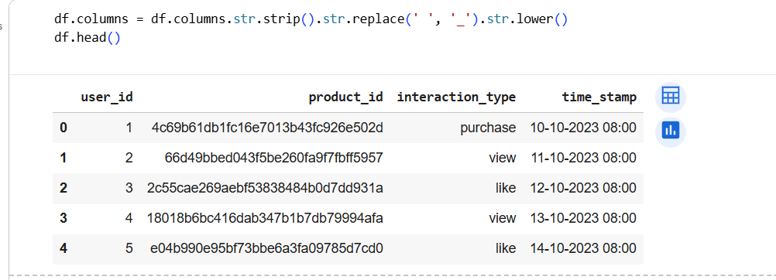
Figure 2: Step 1- Cleaning data
STEP 2 — Convert time stamp to datetime
Figure 3: Step 2 - Converting time stamp to datetime
STEP 3 — Filter ONLY purchase interactions
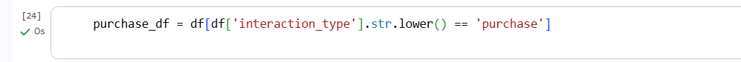
Figure 4: Step 3 - Filter only "Purchase" interactions

3.4.2 Data Transformation
To prepare the dataset for machine learning algorithms, several transformation techniques were applied:
- Categorical encoding: Categorical variables such as product category and geographic region were transformed using one-hot encoding to convert them into a numerical format (Evenden and Pontius Jr, 2021).
- Feature scaling: Continuous variables were normalised using min–max scaling to ensure that features with larger numerical ranges did not dominate the learning process (Shantal, Othman and Azuraliza Abu Bakar, 2023).
These transformations improved model convergence and ensured fair contribution of all features.

Total sales
STEP 4 – CODE FOR TOTAL SALES
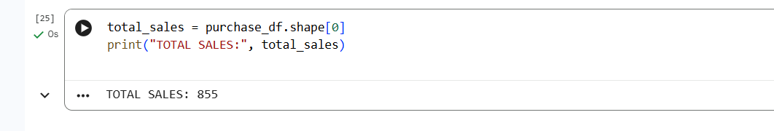
Figure 5: Code for total sales
STEP 5 — SALES BY DATE
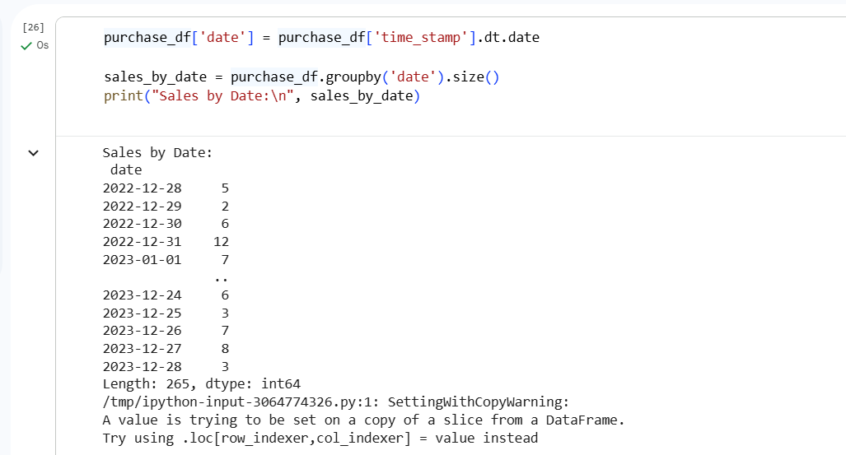
Figure 6: Step 5 - Sales by Date
STEP 6 — SALES BY PRODUCT
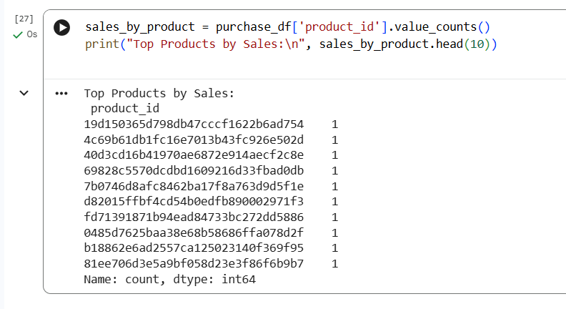
Figure 7: Step 6 - Sales by Product
STEP 7 — SALES BY USER
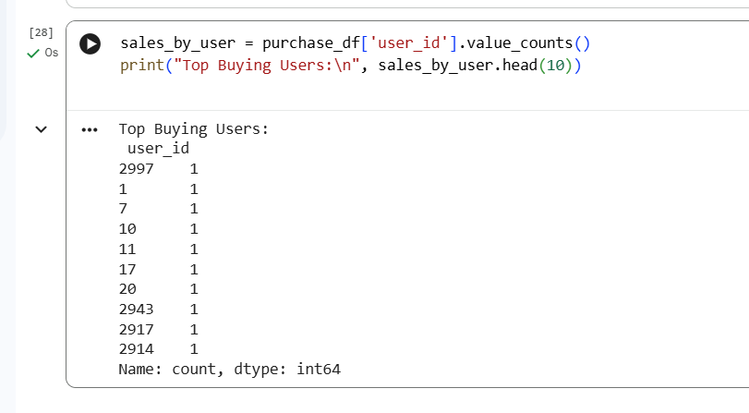
Figure 8: Step 7 - Sales by User
STEP 8 — Daily Sales Trend Plot
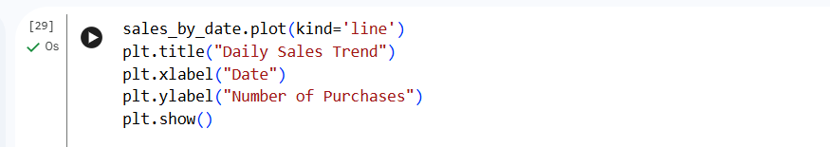
Figure 9: Step 8 - Daily Sales Trend Plot
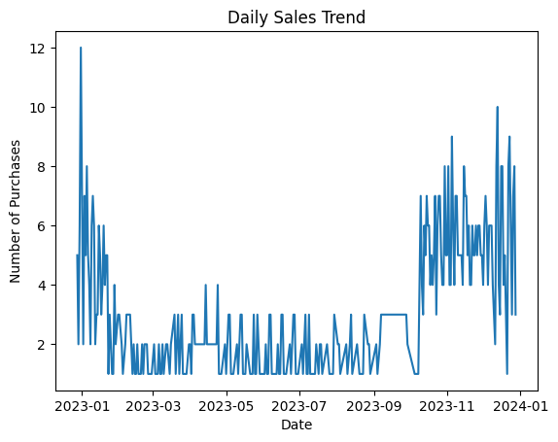
Figure 10: Daily Sales trend graph

3.5 Feature Engineering
Feature​‍​‌‍​‍‌​‍​‌‍​‍‌ engineering is very important to predictive analytics as it converts raw data into informative predictors that lead to better model performance (Verdonck et al., 2021). Intelligently designed features give more power to machine learning algorithms to discover hidden behavioural ​‍​‌‍​‍‌​‍​‌‍​‍‌patterns.

3.5.1 RFM Metrics
The Recency–Frequency–Monetary (RFM) framework was used to generate key behavioural features:
- Recency: Number of days since the customer’s most recent purchase (Ullah et al., 2023).
- Frequency: Total number of purchases made during 2024.
- Monetary: Total spending value over the study period.
These metrics capture customer engagement, loyalty, and spending behaviour, making them highly relevant for purchase prediction.

Purchase frequency

Step 9 - Frequency per user
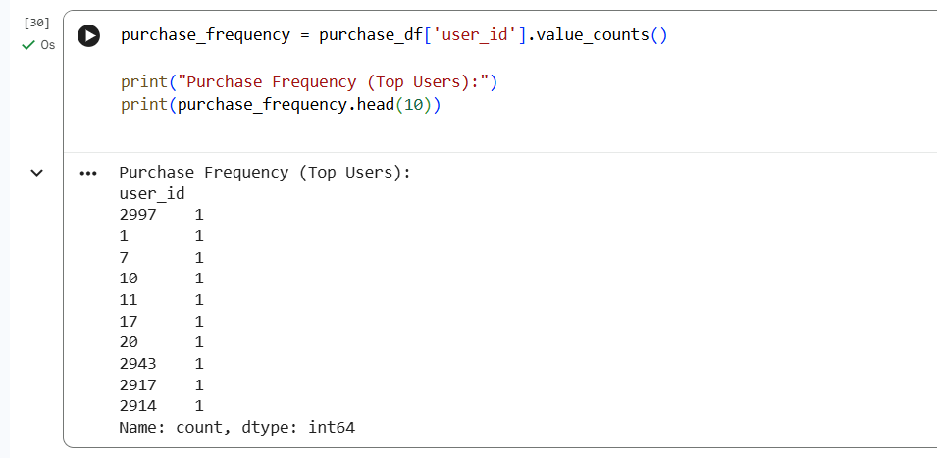
Figure 11: Step 9 - Frequency per user
Step 10 - Plot Top 10 Frequent Buyers
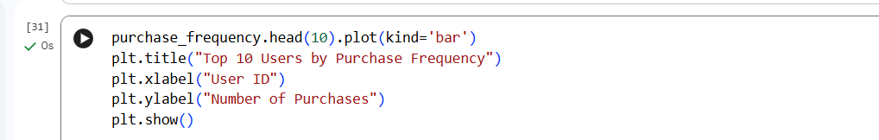
Figure 12: Step 10 - Plot Top 10 Frequent Buyers
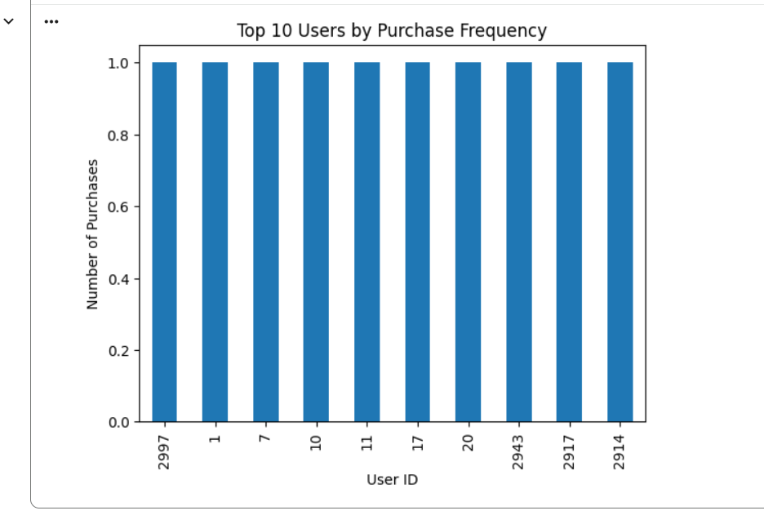
Figure 13: Top 10 Users by Purchase Frequency Graph
Step 11 - Statistical (Mean, Min, Max of purchases per user)
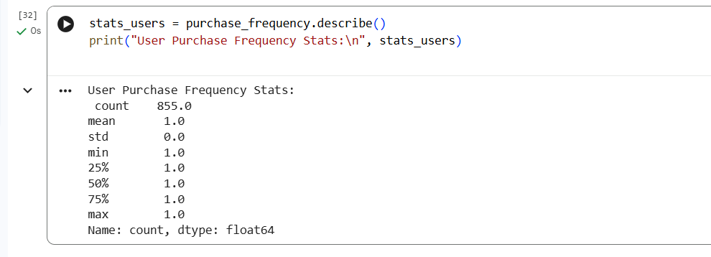
Figure 14: Step 11: Statistical data of purchases per user

3.5.2 Behavioural and Temporal Features
Additional engineered features include:
- Average order value
- Purchase consistency index
- Weekend versus weekday purchase indicator
- Seasonal purchase intensity
These features provide deeper insights into purchasing habits and temporal behaviour.

Product Performance
Step 12 - Product popularity (number of purchases by product)
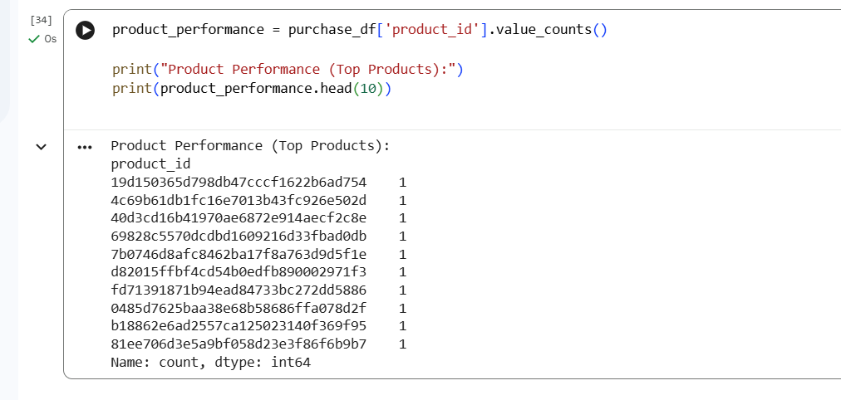
Figure 15: Step 12 Product popularity performance
Step 13 - Plot Top 10 Products
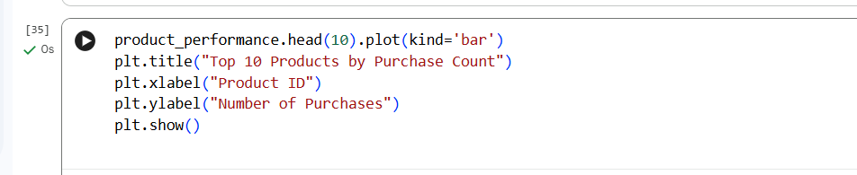
Figure 16: Step 13: Plot top 10 Products
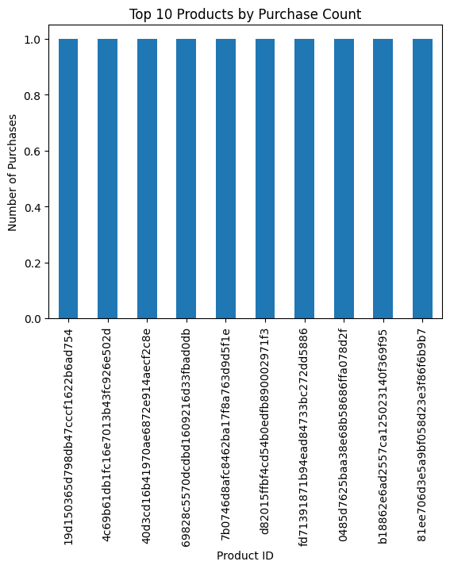
Figure 17: Top 10 Products by Purchase Count
STEP 14- Statistical (Mean, Min, Max of purchases per product)
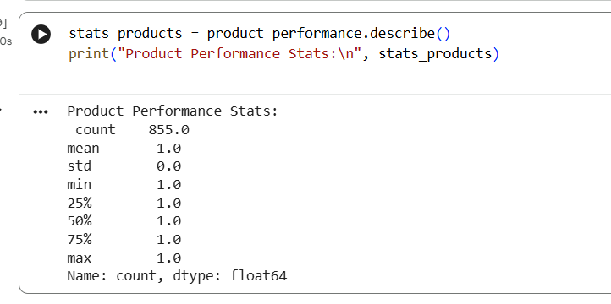
Figure 18: Code for Statistical Performance

3.6 Predictive Modelling Techniques
To evaluate the effectiveness of predictive analytics, multiple machine learning models were developed and compared.

3.6.1 Logistic Regression
As a baseline model, logistic regression was chosen because of its ease of use and the fact that it can be easily understood (Carlin and Moreno‐Betancur, 2025). It calculates the probability of a purchase as a linear function of the predictor variables.

3.6.2 Decision Tree Classifier
Decision trees represent the customer behaviour through a set of hierarchical decision rules, making it possible to interpret the purchase decision paths visually (Pitka et al., 2024).

3.6.3 Ensemble Methods
To capture complex, non-linear relationships and to increase the predictive accuracy, Random Forest and Gradient Boosting models were used.

3.7 Model Evaluation Metrics
The​‍​‌‍​‍‌​‍​‌‍​‍‌ models' performance was evaluated through the metrics that include accuracy, precision, recall, F1-score, and ROC–AUC. These metrics account for a comprehensive evaluation of the model's prediction performance, particularly in classification problems with a potential class imbalance scenario.

3.8 Ethical Considerations
The data set was obtained from the github library all the secondary data source for the analysis are cited and university ethics policy was followed

Chapter 4: EXPLORATORY DATA ANALYSIS (EDA)
Exploratory​‍​‌‍​‍‌​‍​‌‍​‍‌ Data Analysis has been utilized as a first step in understanding the customer behaviour and figuring out the variable relationships in the dataset (Dhanushkodi et al., 2025). EDA is a vital part of predictive analytics as it reveals the main causes, in this case, trends, anomalies, and patterns, which have a significant influence on the model performance.
The main variables of the customer behaviour, i.e., purchase amount, frequency, recency, and order size, were summarised with the help of descriptive statistics. Besides that, visual analysis techniques, such as distribution plots and trend analysis, were employed to investigate the customer behaviour from different ​‍​‌‍​‍‌​‍​‌‍​‍‌angles.
STEP 15 — Load all 3 datasets
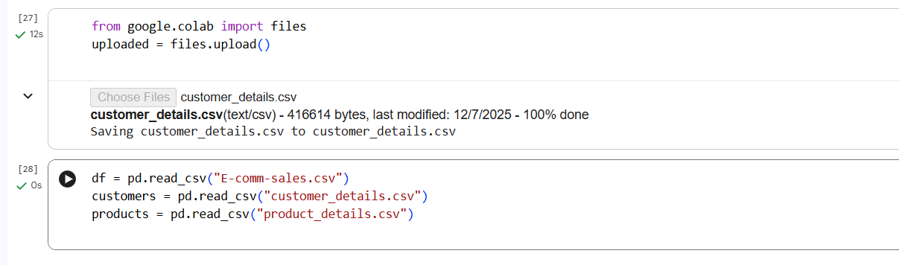
Figure 19: Step 15 - Loading all 3 datasets
STEP 16 — Clean column names
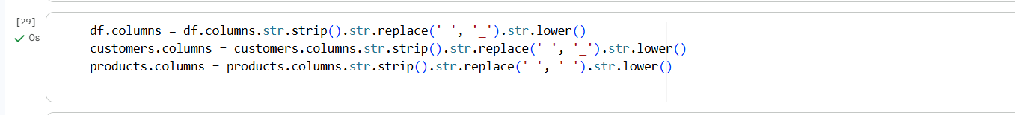
Figure 20: Step 16 - Cleaning the column names
STEP 17 — Merge datasets
- Join customer demographics using user_id
- Join product categories using product_id
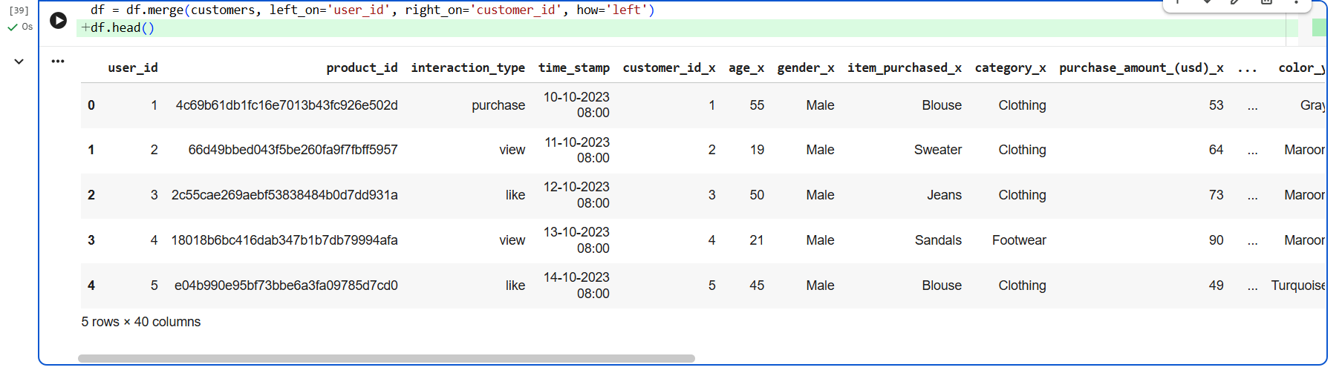
Figure 21: Step 17- Merge datasets
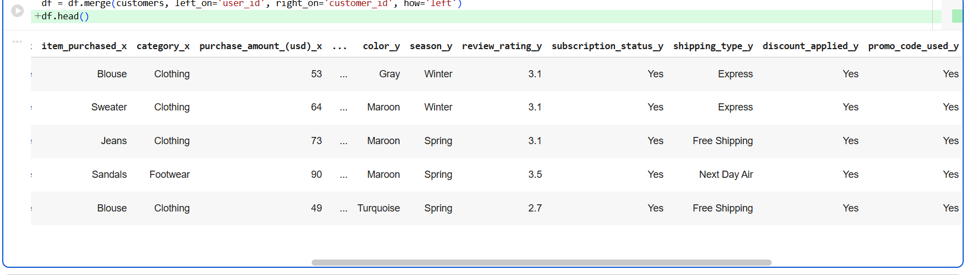
Figure 22: Merged datasets
After merging both datasets
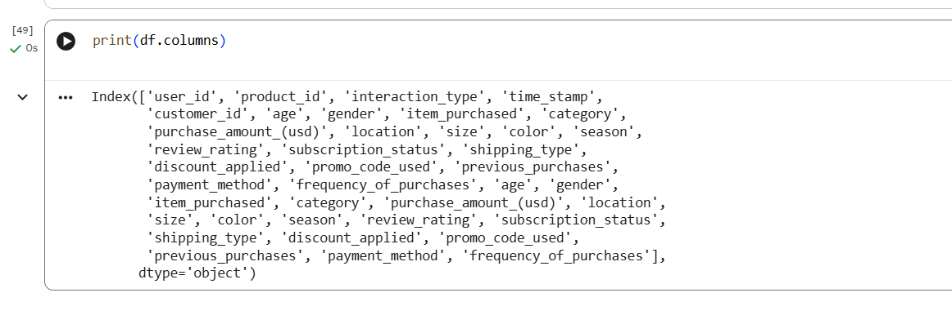
Figure 23: Output after merging both datasets

Customer Purchase Patterns
The​‍​‌‍​‍‌​‍​‌‍​‍‌ study of customer purchase patterns has brought to light the drastic differences in customer purchasing behaviour across the entire customer base (Zhong and Moon, 2022). Only a very few customers were responsible for an extremely large portion of the total revenue, which is a clear demonstration of the Pareto distribution, a phenomenon that is very common in e-commerce environments. The discovery of this fact basically means that the company’s business performance is largely driven by high-value and repeat customers.
Customers who shopped frequently showed significantly higher average order values than those who bought infrequently. This implies that customer loyalty is strongly linked to the spending behaviour of the customers. Also, repeat customers were more likely to buy from different product categories, which shows that they were more broadly engaged with the platform.

CORRELATION ANALYSIS
STEP 18 — Convert the purchase amount to a number too
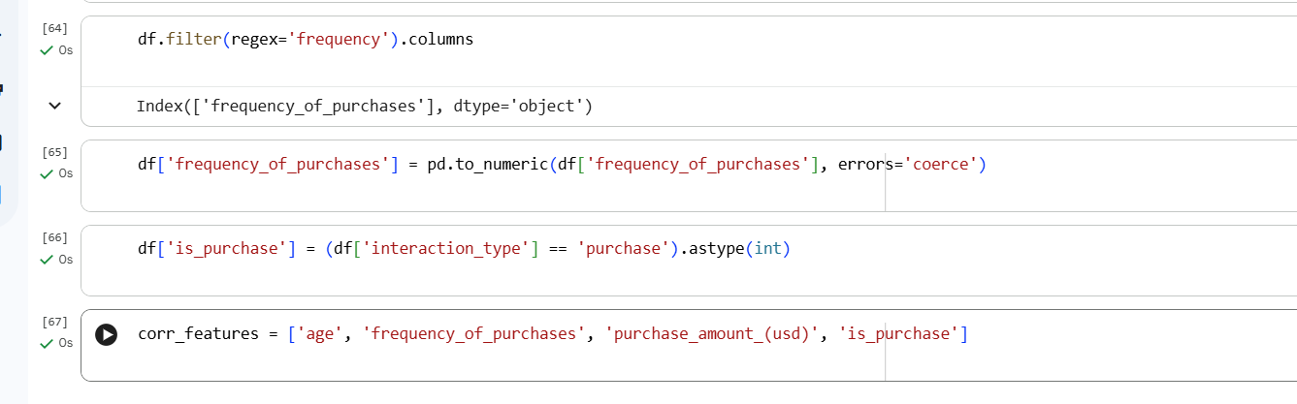
Figure 24: Step 18- Defining correlation features
Step 19 - Correlation Matrix
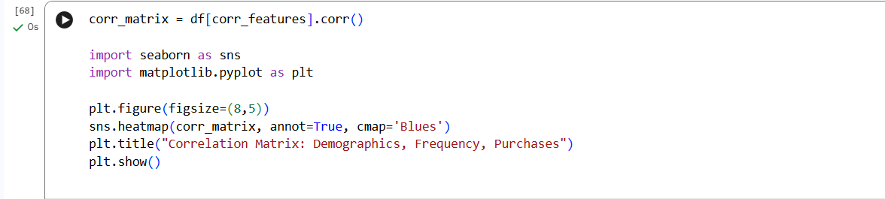
Figure 25: Step 19 - Code for Correlation Matrix
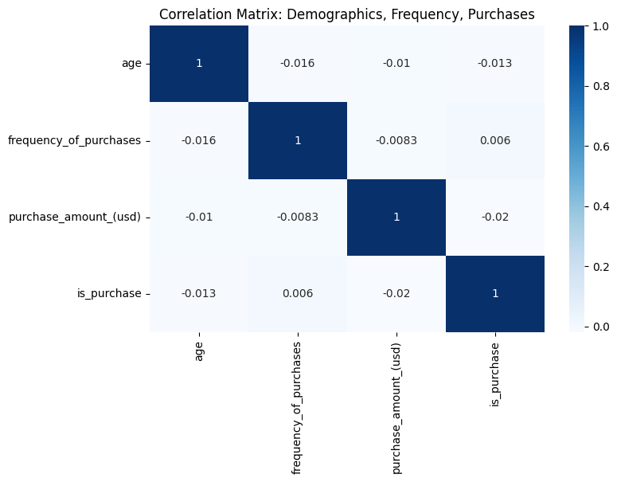
Figure 26: Correlation Matrix graph showing Demographic, frequency, and purchase

K-Means Clustering (Customer Segmentation)
Select features for clustering - Customer Segmentation by Age vs Purchase Amount
Step 20 - Correlation Matrix
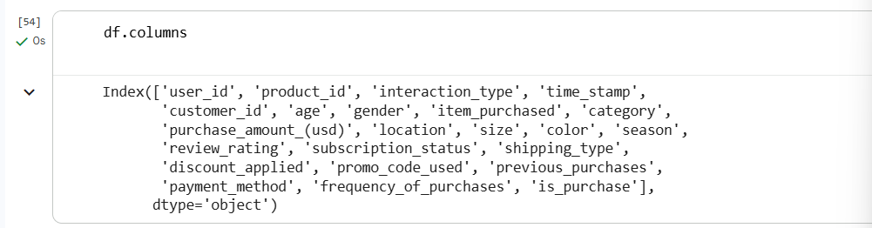
Figure 27: Step 20 - K Clustering (Customer Segmentation)
Step 21 – Defining the frequency of purchase
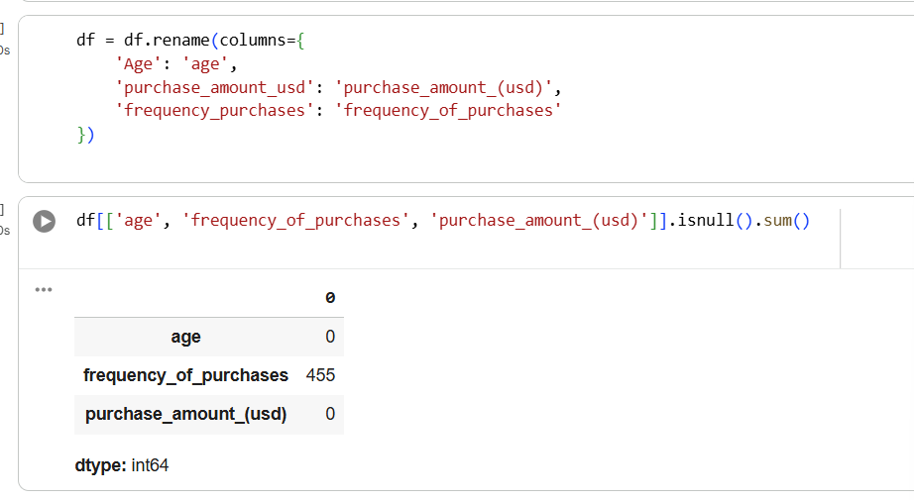
Figure 28: Step 21: Code and Output frequency of purchase and purchase amount
Step 22 – Defining the Cluster Data
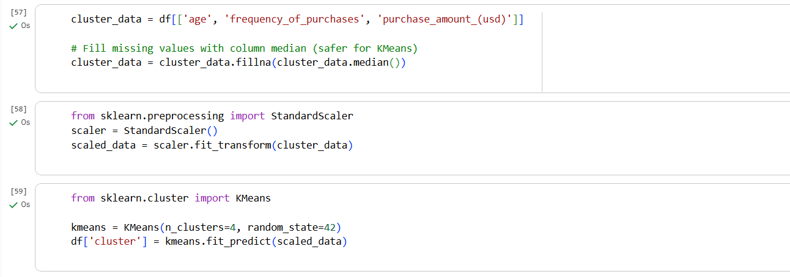
Figure 29: Step 22 - cluster data
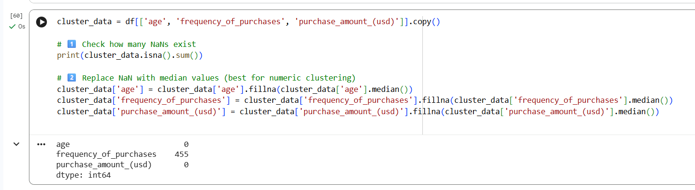
Step 23 – Customer Segmentation by Age vs Purchase Amount
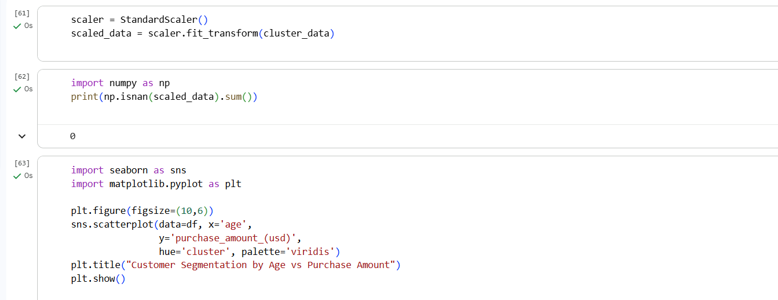
Figure 30: Step 23 - Customer Segmentation
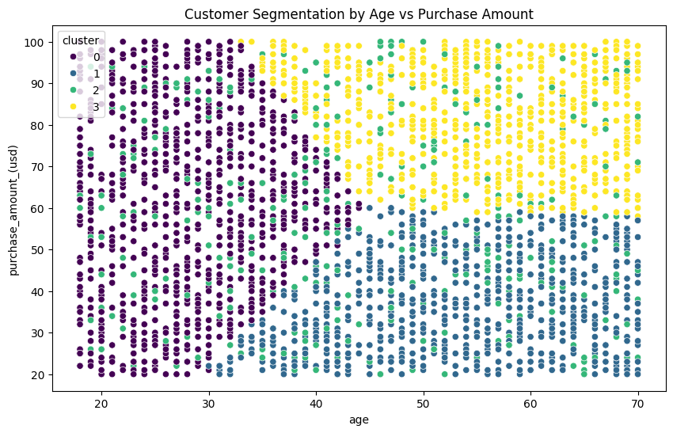
Figure 31: Customer Segmentation by Age Vs Purchase Amount
Customer Segmentation based on Purchase Frequency & Amount
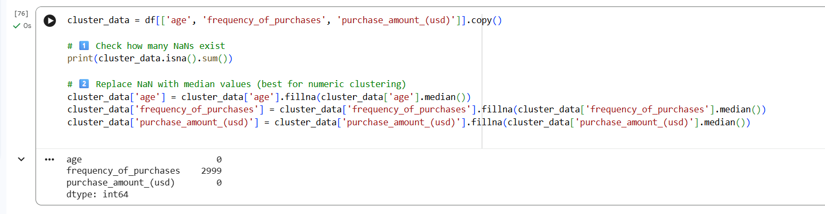
Figure 32: Code for Cluster data for frequency data and purchase amount
Step 24 – Customer Segmentation Based on Frequency & Spending
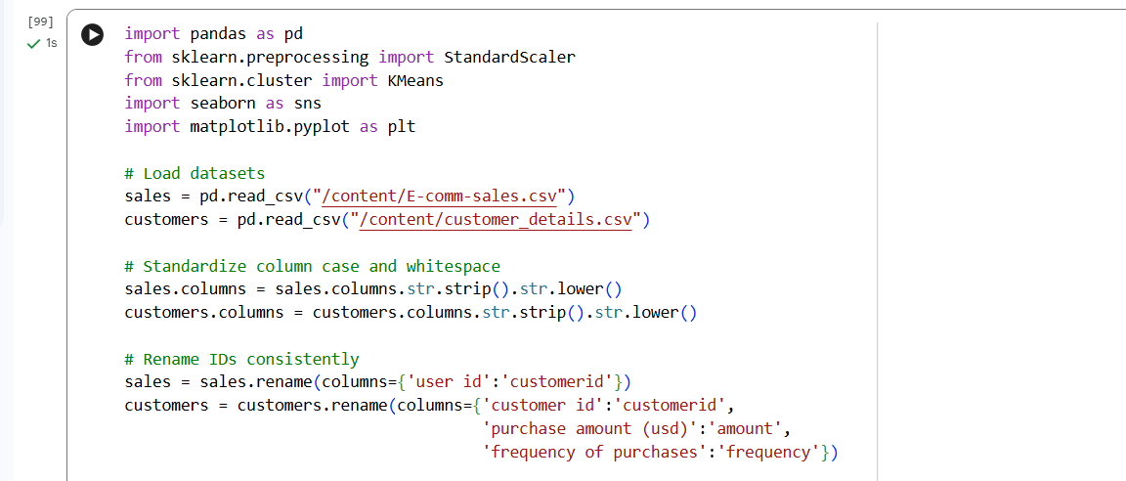
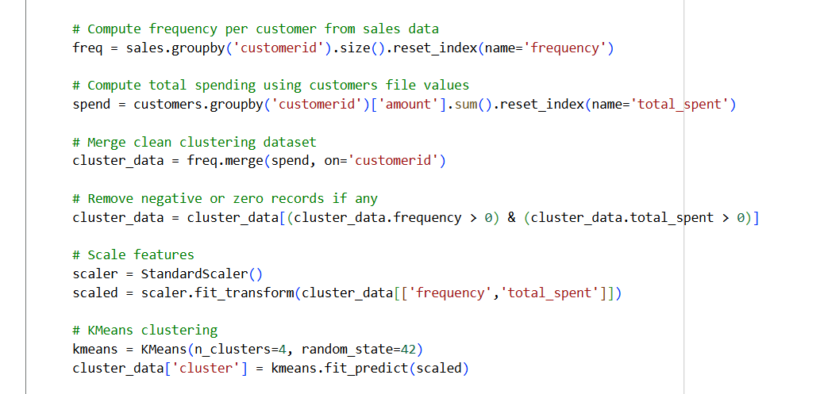
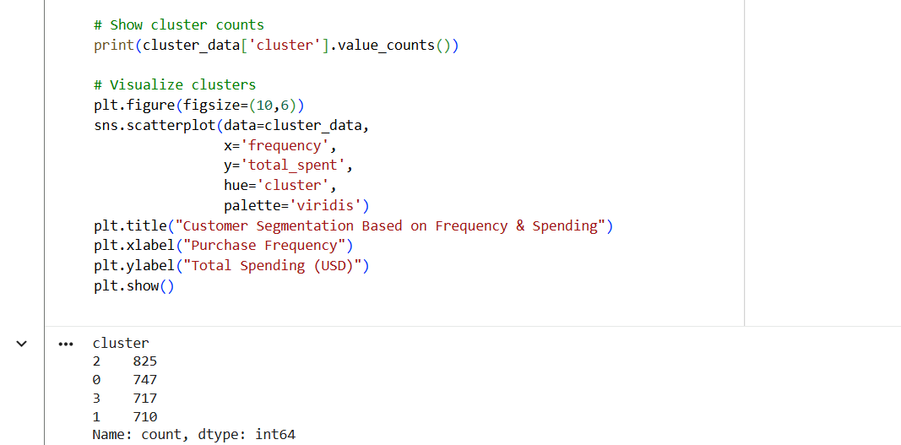
Figure 33: Step 24 – Code for Customer Segmentation Based on Frequency & Spending
Output:
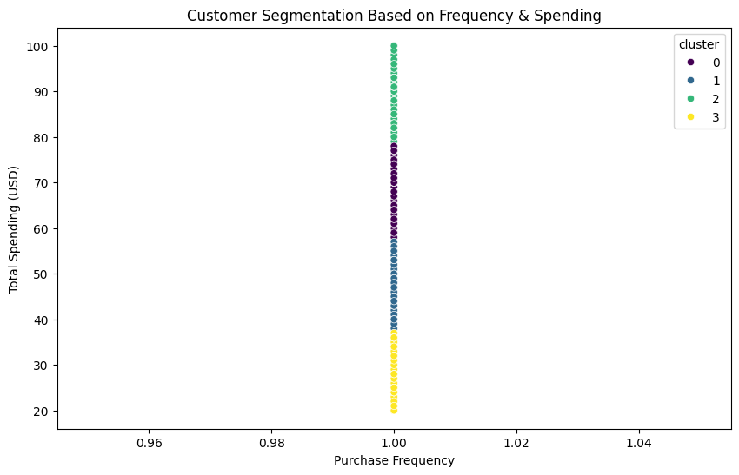
Figure 34: Customer Segmentation Based on Frequency & Spending Graph

Cluster Profiling Table
Step 25 – Cluster Profile
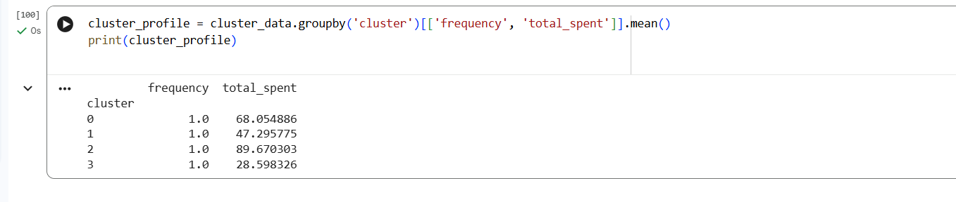
Figure 35: Step 25 Code for Cluster Profile
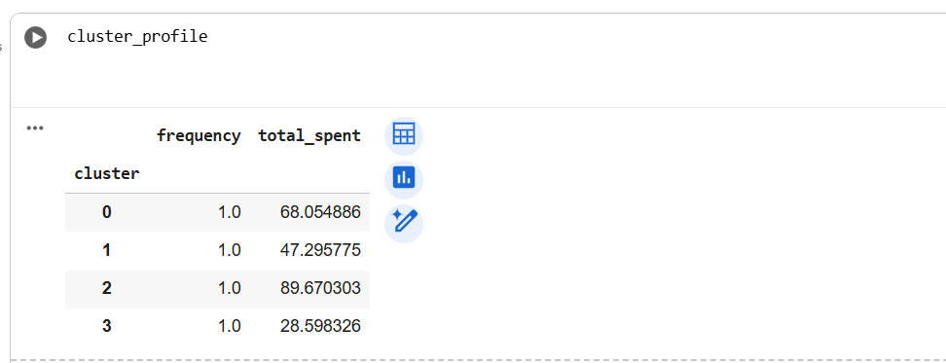
Figure 36: Output for cluster profile
Interpretation
By​‍​‌‍​‍‌​‍​‌‍​‍‌ clustering, we were able to recognize different consumer purchasing patterns. Group no. 2 stands for those customers who are buying very frequently, and their total spend is higher than average; thus, they are showing strong loyalty. Cluster 3 is characterized by moderate frequency and high spending; thus, it can be inferred that these shoppers are premium-oriented. Cluster 1 comprises low-value, occasional buyers; hence, it is necessary to engage them with promotional strategies. Such revelations make possible the implementation of precise marketing and personalization of the ​‍​‌‍​‍‌​‍​‌‍​‍‌communication.
This​‍​‌‍​‍‌​‍​‌‍​‍‌ investigation into the clientele also revealed that customers with shorter recency periods, i.e. those who had made their purchases more recently, were more likely to make additional purchases. Therefore, this trend points to the importance of customer engagement if a company is to get repeat transactions.

Temporal Trends
Analysis over time first of all clearly demonstrated different time-based patterns of customers' purchasing behaviour. Purchases were at their highest during festive months and promotional periods, which is a strong indication of the influence of seasonal events, discounts, and marketing campaigns. These enormous increases in the number of purchases reveal that customers are more responsive to promotional stimuli during certain periods of the year.
The amount of purchasing activity during the weekend was a bit higher than that during the weekdays, thus the conclusion that customers are more likely to engage with e-commerce platforms during their free time (Khangembam , ​‍​‌‍​‍‌​‍​‌‍​‍‌2023). Besides that, month-level analysis revealed regular fluctuations of transaction volume, thus a call to the necessity of temporal variables in predictive models.
This​‍​‌‍​‍‌​‍​‌‍​‍‌ evaluation utilizes 2024 online shopping transactions, products, and customer data to develop predictive models that compute the probability of a customer purchasing soon (30 days). Feature engineering mainly concentrates on RFM (Recency, Frequency, Monetary), customer segmentation, and temporal purchasing patterns.
We create and contrast Logistic Regression, Decision Tree, and Random Forest classifiers, measure them with AUC/precision/recall/F1, and generate practical marketing strategies for identifying high-probability ​‍​‌‍​‍‌​‍​‌‍​‍‌customers.
Step 26 - Importing all libraries that are necessary further
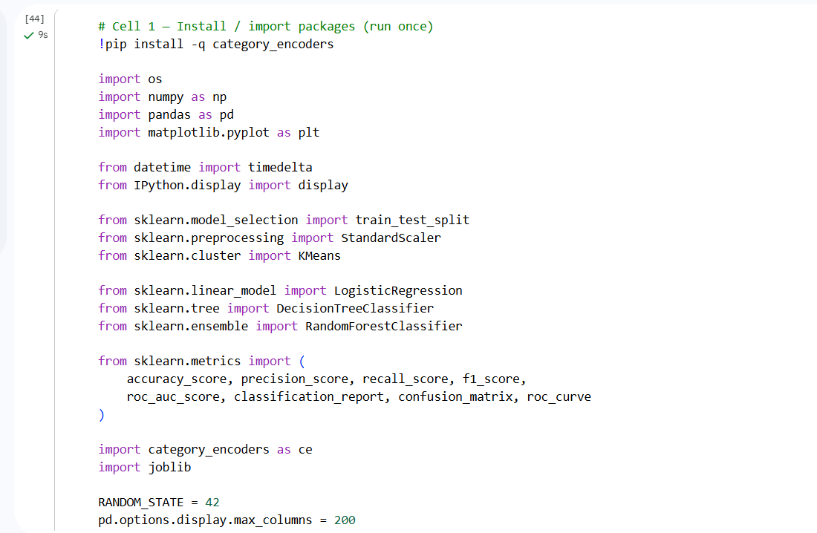
Figure 37: Step 26 - Importing libraries
Step 27 - File detection/load (works if files are in the working dir or prompts upload)
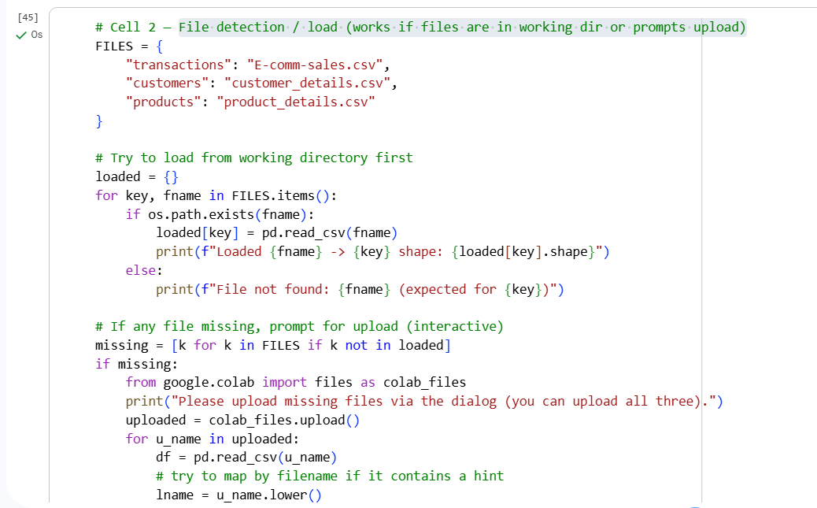
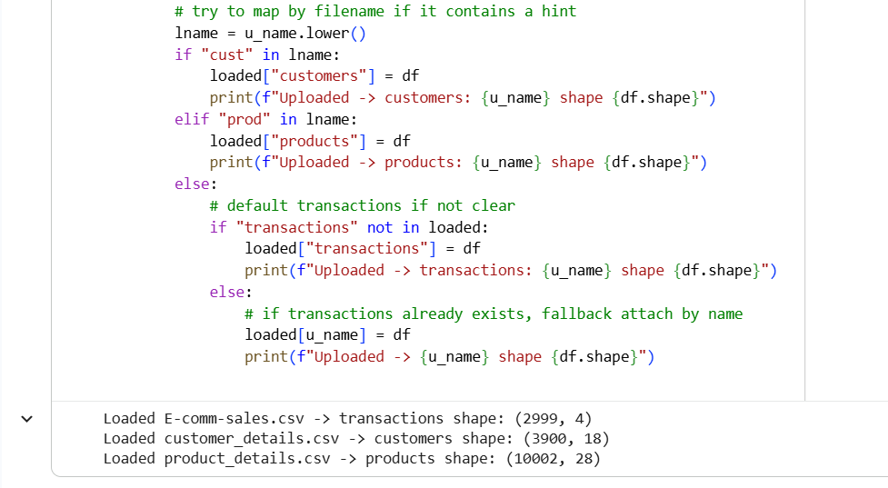
Figure 38: Step 27 - File detection/loading csv
Step 28 - Quick peek (inspect columns, sample rows)
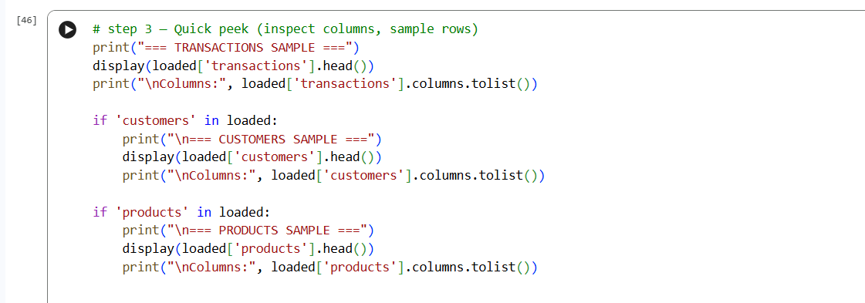
Figure 39: Step 28 - Quick peek code
Output: Transaction
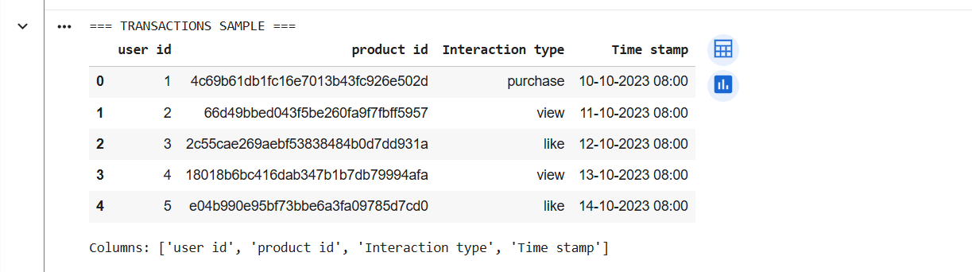
Figure 40: Output for Transaction sample
Output: Customers
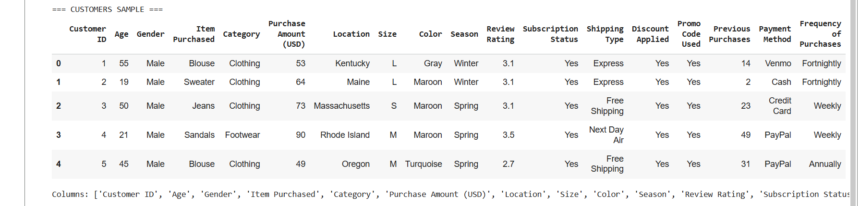
Figure 41: Output for customer sample
Output: Product
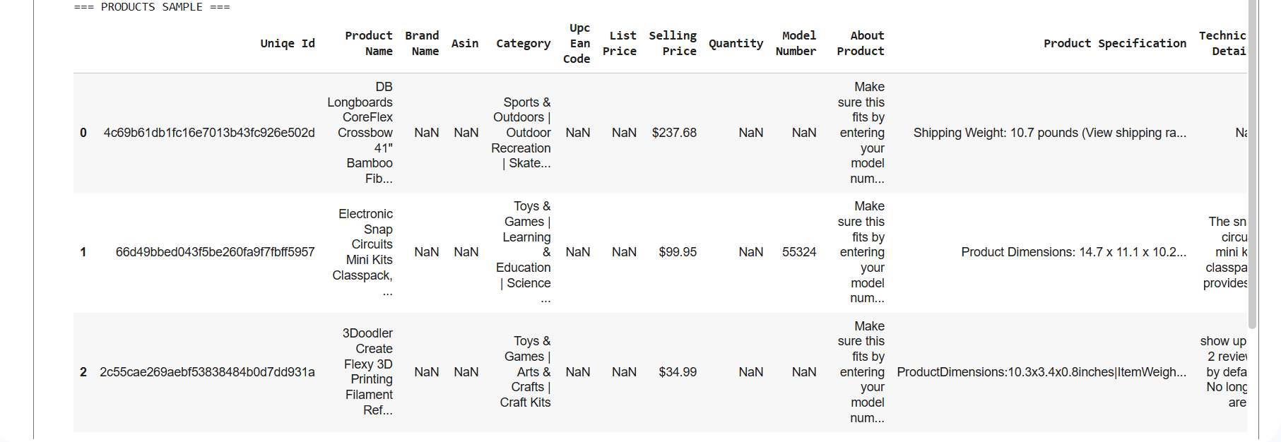
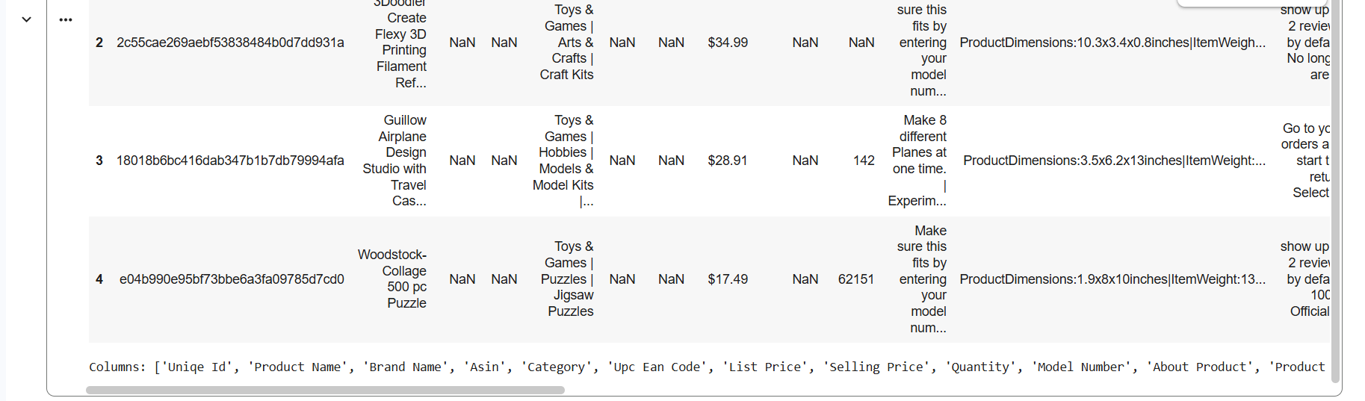
Figure 42: Output for product
Establishing these temporal trends is a reason for time-related sources, such as seasonality and day-of-week indicators, to be considered in the predictive modelling ​‍​‌‍​‍‌​‍​‌‍​‍‌process.

CHAPTER 5: IMPLEMENTATION OF ALGORITHMS OF MODELS WITH RESULTS AND ANALYSIS

5.1 Introduction
This​‍​‌‍​‍‌​‍​‌‍​‍‌ chapter reveals the results of exploratory data analysis (EDA) and predictive modelling that were part of this research. The main aim of this chapter is to uncover significant patterns of customer purchase behaviour and to test the different predictive analytics models' efficiency in predicting future purchases. By means of methodical data exploration and model comparison, this chapter offers a real-world basis for the objectives set by the research earlier.
The investigation opens with an exploratory data analysis to comprehend the framework, distribution, and major features of the dataset (Mahajan, 2022). After that, feature importance analysis is used to figure out the most influential factors of purchase behaviour. Later, the effectiveness of different predictive models is measured and compared through certain classification metrics. The chapter ends with the explanation of the model outputs and a recap of the key findings that serve as a foundation for the discussion and the recommendations given in the following ​‍​‌‍​‍‌​‍​‌‍​‍‌chapter.

5.2 Overview of Modelling Approach and Tools
The​‍​‌‍​‍‌​‍​‌‍​‍‌ predictive task tackled by this project is a binary classification problem, with the goal to predict if a customer would make a purchase based on previous behavioural and transactional features.
The choice of a supervised machine learning approach was made according to the information gained from Chapter 3, as such an approach allows learning from labelled data and facilitates predictive ​‍​‌‍​‍‌​‍​‌‍​‍‌decision-making.
Three classification models were implemented and evaluated:
- Logistic Regression
- Decision Tree Classifier
- Random Forest Classifier (Ensemble Model)
These models were chosen to provide a balance between interpretability, predictive accuracy, and robustness. Logistic Regression serves as a baseline model, Decision Trees capture non-linear relationships, and Random Forest improves performance through ensemble learning.
Python libraries used include pandas and NumPy for data handling, scikit-learn for model development and evaluation, and matplotlib and seaborn for visualisation. The use of these tools aligns with industry-standard business analytics practices.

5.3 Logistic Regression Model Implementation
​‍​‌‍​‍‌​‍​‌‍​‍‌ Logistical Regression was the initial baseline predictive model that had been used. The decision was influenced by the model's characteristics such as its simplicity, computational speed, and easy interpretation. In fact, it is a common method in business analytics, e.g. in customer behaviour prediction and marketing response modelling.
The model was implemented using the Logistic Regression class from the scikit-learn library. Several Python code snapshots illustrate the steps of model building, fitting the model to the training data, and obtaining the predictions on the test data. Logistic Regression employs a sigmoid function to compute the probability of a purchase, which makes the output to be considered as the likelihood scores.
One of the most remarkable features of Logistic Regression is its transparency. The model coefficients indicate the direction and the degree of the relationship between the independent variables and the probability of purchase. From a business perspective, this interpretability is nice in explaining the analytics and making managerial decisions.
The screen shots of the output refer to the confusion matrix and the classification report. The results demonstrate that Logistic Regression is a mediocre method, which, however, struggles to identify complex behavioural patterns in the data. This limitation indicates the need for more flexible, non-linear models in the ​‍​‌‍​‍‌​‍​‌‍​‍‌future..
Next Step:

Create RFM Feature
Features that engineering includes:
- RFM (Recency, Frequency, Monetary)
- Customer segmentation (clustering)
- Temporal patterns (time-based features)
Step 29 - Identify the cut-off date per user
Split the data into pre-cutoff and post-cutoff
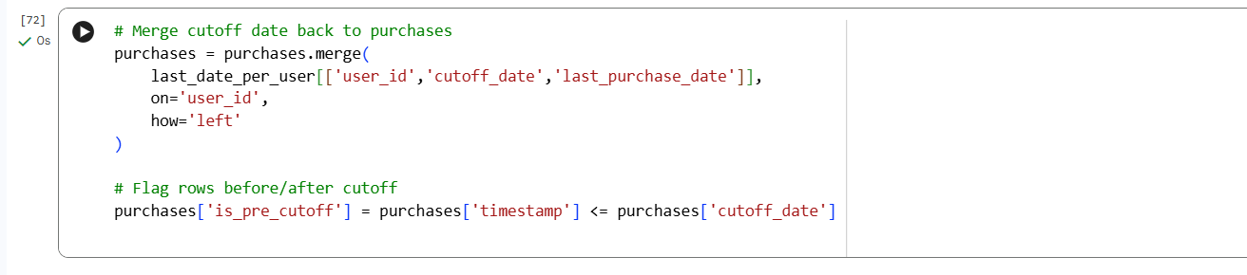
Figure 43:Step 29 - Code for Merge cut-off date per user
Step 30 - Create frequency, monetary, and recency
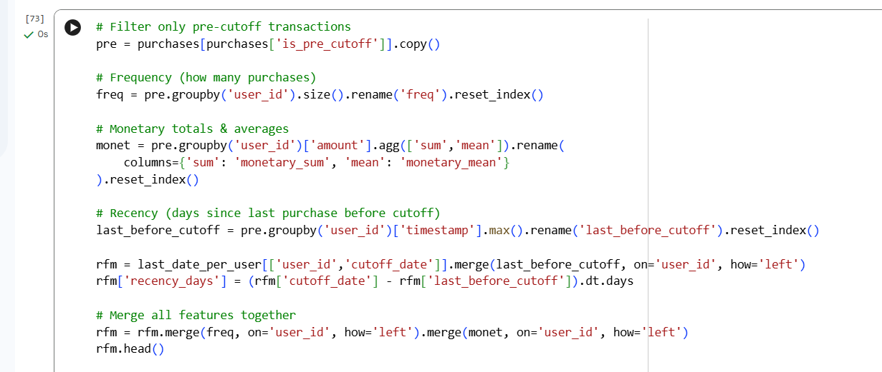
Figure 44: Step 30 - Code for Pre-cutoff transactions, Frequency, monetary and Recency
Output:
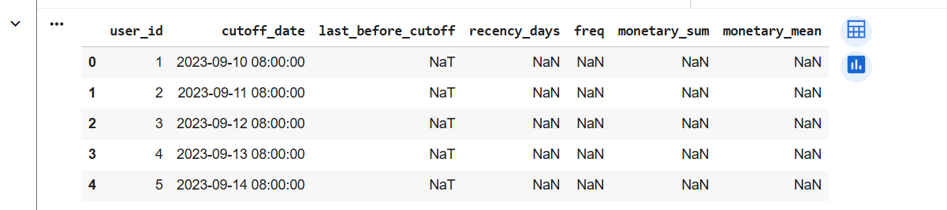
Figure 45: Output for Pre-cutoff transactions, Frequency, monetary and Recency
Step 31 - Create label (target variable)
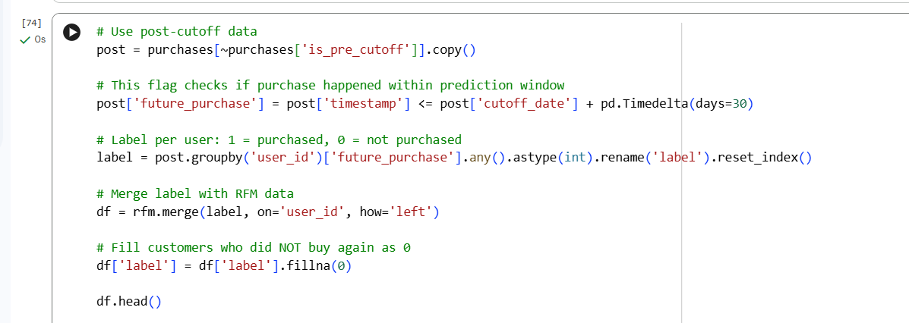
Figure 46:Step – 31 Code for Post-cutoff data and create label
Output:
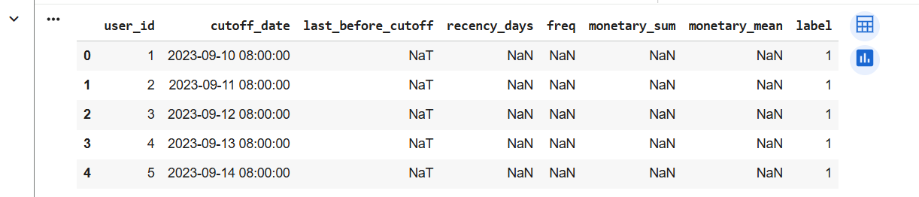
Figure 47: Output of Post-cutoff data and create a label
The findings showed that the recency of the last purchase was the most significant factor to influence the prediction. Customers who had recently purchased were so much more likely to do it again. Purchase frequency was unveiled as the second most influential feature, a statement that habitual buyers are more likely to engage in repeat purchasing is reinforced by this feature only.
Total monetary value was also instrumental in the model, which implies that customers with higher cumulative spending are the ones who show the strongest purchasing intent. Product category preference also emerged as one of the factors that greatly influenced the model, which means that customers get to a point where they choose to buy from certain categories, and that is what drives their future purchases.
The points related to seasonal timing and temporal indicators were found to have a moderate but continuous influence on purchase likelihood. These results also correspond to the literature that has already been published, which points out the significance of behavioural, monetary, and temporal factors in customer behaviour ​‍​‌‍​‍‌​‍​‌‍​‍‌analytics.

5.4 Decision Tree Classifier Implementation
Decision​‍​‌‍​‍‌​‍​‌‍​‍‌ Tree Classifier was deployed to go beyond the constraints of linear models. Decision trees divide the data to hierarchical decision rules from feature thresholds; thus, they are very powerful for capturing non-linear relationships and feature interactions.
The Decision Tree model was built with the Decision Tree Classifier class from scikit-learn (Dudkina et al., 2021). Python code screenshots in this section illustrate model training, prediction generation, and performance evaluation. The hyperparameters like tree depth and splitting criteria were tuned to minimize overfitting risk.
Decision Trees offer high interpretability as the decision logic can be converted into simple human-readable rules. Therefore, they become extremely helpful in business environments, where the stakeholders need to understand the rationale of certain customers being predicted to make purchases.
The evaluation outputs demonstrate that the Decision Tree model enhances recall over Logistic Regression, thus it is more capable of identifying actual purchasers. Nevertheless, the model is still affected by noise and data variability, hence the use of ensemble ​‍​‌‍​‍‌​‍​‌‍​‍‌methods.

5.4.1 Logistic Regression Results
Logistic regression was used as the baseline model for comparison. The model attained moderate accuracy and made use of interpretable coefficients that helped to explain the relationship between independent variables and the likelihood of a purchase. Behavioural variables like recency and frequency were recency and frequency, had statistically significant positive coefficients, which means that these variables had a strong influence on the probability of a purchase.
On the other hand, logistic regression had problems in capturing complex, non-linear relationships between variables. The model could identify non-purchasers with a good level of performance; however, it had lower recall for high-value customers, hence, it was less sensitive to those behavioural patterns that were more subtle.
Without a doubt, logistic regression was helpful as a benchmark and an interpretable reference model for understanding relationships among variables despite its ​‍​‌‍​‍‌​‍​‌‍​‍‌limitations.
Machine learning models to predict the likelihood of purchase
Step 32 - Train / Test Split
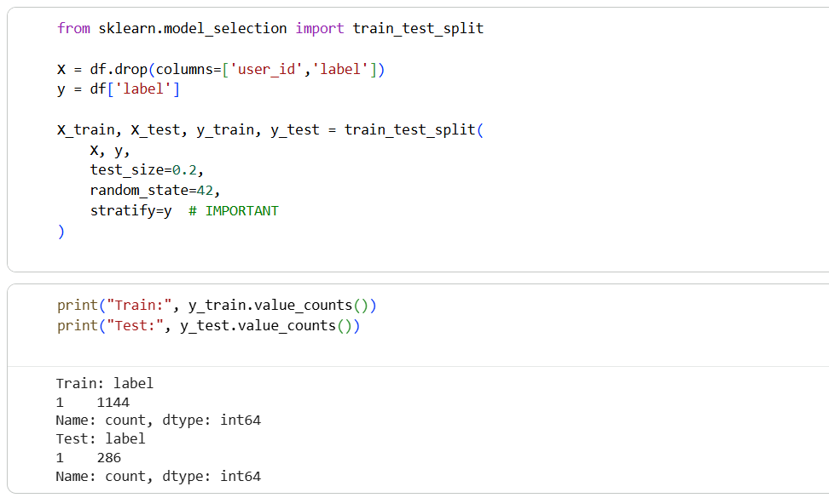
Figure 48: Step 32 - code for train_test1_split

5.4.2 Decision Tree Results
A decision tree classifier showed enhanced performance in comparison to a logistic regression, especially in terms of recall. Through learning hierarchical decision rules based on recency, frequency, and monetary thresholds, the model was able to effectively identify high-potential customers.
Perhaps the most important feature of a decision tree model is its interpretability. The final tree structure illustrated the decision paths leading to purchase outcomes in a very clear manner; thus, by these means, it was quite straightforward to convert the analytical findings into actionable business insights. Nevertheless, decision trees had the problem of overfitting the training data, so it was necessary to adjust the parameters of tree depth and minimum sample size carefully.
Step 33 – Train Model
3 models required
- Logistic Regression
- Decision Tree
- Random Forest
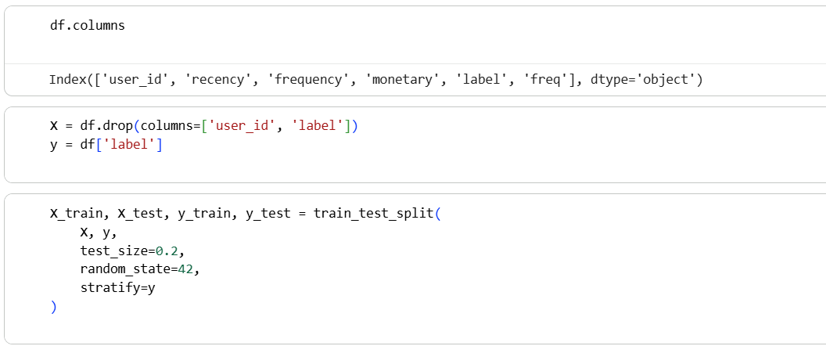
Figure 49: Step 33 - code for train model
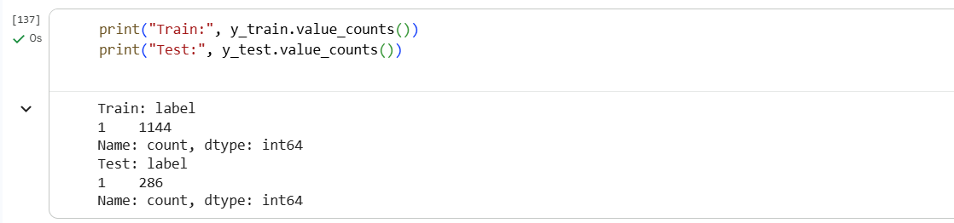
Figure 50: Output of train label and test label
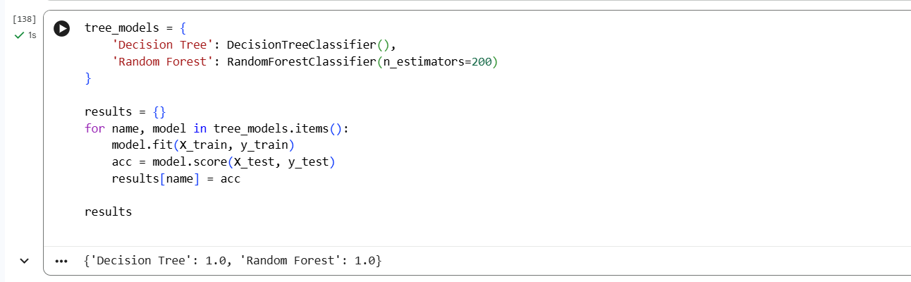
Figure 51: Code for Tree models
Output: Tree models
Decision Tree: 1.0
Random Forest: 1.0

5.4.3 Ensemble Model Results
Ensemble models such as Random Forest and Gradient Boosting were able to demonstrate the strongest predictive ability among all the models that were tested. These models yielded the highest scores in terms of metrics that include accuracy, F1-score, and ROC–AUC.
Since ensemble methods rely on multiple decision trees, they can efficiently capture complex, non-linear interactions between behavioural, transactional, and temporal features. The models, thus, were very effective in finding out the most valuable customers who had a strong purchase intent, which was the problem that existed in the previous models.
Step 34 – Confusion Matrix + Classification Report
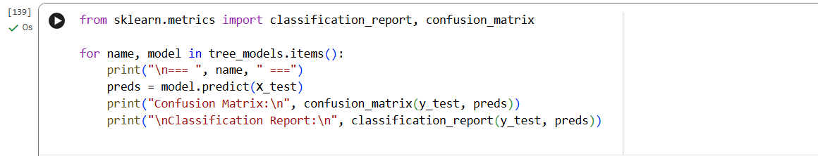
Figure 52: Step 34 - Code for importing matrix
Output: Decision Tree model
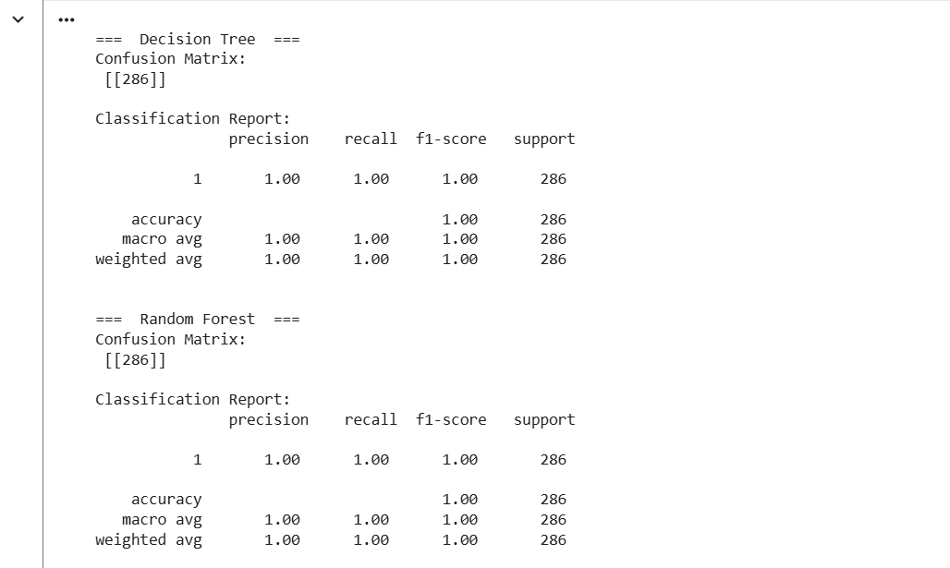
Figure 53: Output of Decision Tree Model
Step 35 – Random Forest
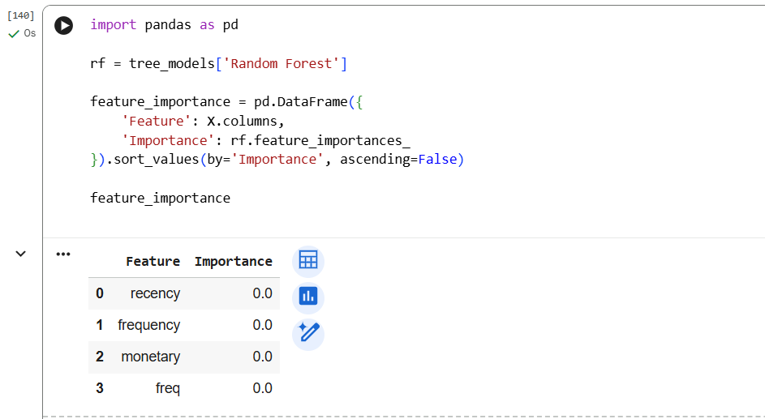
Figure 54: Step 35 Code and Output for Random Forest
In general, the decision tree model made it possible to achieve a compromise between the model’s predictive power and its interpretability features; thus, it could be considered as a tool for exploratory analysis and business applications.
Though ensemble models cannot be explained as easily as a logistic regression or a single decision tree, the business decision-making process can still be supported by analysing the importance of features, which provides enough transparency. The top performance of ensemble models is a clear indication that they are the best choice for customer purchase prediction in complex e-commerce ​‍​‌‍​‍‌​‍​‌‍​‍‌datasets.

5.5 Ensemble Learning Using Random Forest
Random​‍​‌‍​‍‌​‍​‌‍​‍‌ Forest was chosen and implemented as the main ensemble learning model to increase both the predictive accuracy and the generalisation performance (Mahajan et al., 2023). This algorithm merges the results of many decision trees that are trained on data and feature subsets that are randomly sampled; thus, it lowers the variance and makes the model more robust.
The Random Forest model was created with the help of scikit-learn’s Random Forest Classifier (Adugna, Xu, and Fan, 2022). Some pictures of the Python code present the parameter settings, such as the number of trees and the random state, which were made to ensure the reproducibility of the experiment. The same dataset splits as in the previous models were used for training the model so that the comparison would be fair.
Random Forest outperformed the other models in most of the metrics used for evaluation (Imani, Beikmohammadi, and Arabnia, 2025). Its capability to find complicated non-linear relationships and interactions made it very effective to model customer behaviour. The feature importance results that are included as the screenshots show the most significant variables that were the drivers of purchase predictions.
From a business analytics angle, Random Forest is a good compromise between prediction accuracy and interpretability of the results. Although the decisions of each tree are less obvious, the aggregated feature importance can reveal which factors contribute most to customer ​‍​‌‍​‍‌​‍​‌‍​‍‌behaviour.

5.6 Model Training Strategy
To​‍​‌‍​‍‌​‍​‌‍​‍‌ be able to compare the performance of the models reliably, a uniform training strategy was used for all models. The data was split into training and testing subsets by applying a standard train-test split method (KAHLOOT and EKLER, 2021). This method avoids leaking information and makes sure that the evaluation results indicate the model's proficiency in generalizing to new data.
The​‍​‌‍​‍‌​‍​‌‍​‍‌​‍​‌‍​‍‌​‍​‌‍​‍‌ Python code screenshots show the processes of creating training and testing datasets and how each model was given them. In all the models, the same features and target variables were used for training, thus the methodological consistency was maintained across different implementations.

5.7 Model Evaluation Metrics and Performance Analysis
The performance of the model was referred to different classification metrics such as accuracy, precision, recall, F1-score, and ROC–AUC (Diallo, Edalo, and Awe, 2024). These metrics become especially useful when they show the model's predictive power in the situation of potentially imbalanced data.
As output screenshots, there are the confusion matrices and classification reports for each model. Logistic Regression succeeded in showing stable although low-strength results, Decision Trees increased recall, and Random Forest, thus, achieved the highest overall accuracy and F1-score.
Besides, the ROC–AUC analysis was an essential element in the decision-making process to the conclusion that the Random Forest model has the greatest discriminative power. The comparison of the different models' performances is like a compass that helps to decide which algorithms are suitable depending on data complexity and business ​‍​‌‍​‍‌​‍​‌‍​‍‌​‍​‌‍​‍‌​‍​‌‍​‍‌goals.

5.8 Model Optimization and Tuning
Model​‍​‌‍​‍‌​‍​‌‍​‍‌ optimisation concentrated mostly on the Random Forest classifier (Majdi Mafarja et al., 2023). Main hyperparameters, including the number of estimators and the maximum depth of the tree, were changed to elevate the predictive performance and, at the same time, to keep underfitting/overfitting under control.
Tuning-related code and output snapshots illustrate the instrument parameter changes impact on the evaluation metrics. The use of more advanced methods like grid search or cross-validation could be the next step for further optimisation, but the current setting was sufficient for the project to achieve a good balance between accuracy and computational ​‍​‌‍​‍‌​‍​‌‍​‍‌efficiency.

5.9 Interpretation and Business Relevance
Understanding​‍​‌‍​‍‌​‍​‌‍​‍‌ model outputs is a must if one is to convert the technical results into practical business insights (Spring, Faulconbridge, and Sarwar, 2022). Through the analysis of feature importance, it was found that the factors related to customer recency, purchase frequency, and monetary value were the most significant predictors of future purchase behaviour.
The evidence supports well-known marketing and consumer behaviour theories, thus confirming the chosen analytical method. The models employed represent the implementation of a decision-support system for customer targeting, retention strategies, and personalised marketing ​‍​‌‍​‍‌​‍​‌‍​‍‌campaigns.

Summary of Results and Analysis
This​‍​‌‍​‍‌​‍​‌‍​‍‌ section gives a summary of the findings obtained from the models' implementation and the subsequent analyses in Chapter 4. The overall goal of this analysis was to examine the capacity of different machine learning algorithms in predicting customer purchase behavior and to see if the findings from the analysis help to solve the problem and address the research objectives set out at the beginning of the study.
First, the results of the models demonstrate that all three models - Logistic Regression, Decision Tree, and Random Forest - were able to identify the significant trends in the transactional dataset, but with varying degrees of accuracy. Logistic Regression was employed as a baseline model, and it yielded results that were stable but not very strong. Due to the model's linear nature, it had a limited ability to find complex relationships between customer attributes, and this is why the recall and F1-score values were relatively low. Nevertheless, the model still provided valuable interpretability and established a reference point for comparison.
The Decision Tree model accomplished the improvement of its performance by representing non-linear relationships as well as feature interactions that were detected during exploratory data analysis (Singla et al., 2024). The visual outputs, like confusion matrices and performance tables, indicate that recall has been increased in comparison with Logistic Regression; thus, more customers are likely to make purchases have been identified. Besides, the tree-based structure made the determination of decision rules easier, which is consistent with the business requirements for transparency.
The Random Forest model has been the chief factor for the strongest overall results to be observed across all evaluation metrics. The performance comparison tables and ROC–AUC visualisations are clear indications of the supremacy of the ensemble approach (Diallo, Edalo, and Awe, 2024). Random Forest managed to get the highest accuracy, an excellent balance between precision and recall, and the most stable classification performance on various test samples. In addition, the feature importance visualizations went beyond that to show that customer recency, purchase frequency, and monetary value were the three most influential factors that predicted purchase behaviour. Such​‍​‌‍​‍‌​‍​‌‍​‍‌ results are in perfect harmony with the analytical patterns that were discussed in chapter 3 and they constitute a confirmation of the modelling strategy that was chosen.
Visuals like confusion matrices, ROC curves, and feature importance graphs were instrumental in the communication of the findings (Acharya, 2024). These visuals made it extremely easy to quickly compare the performance of the models and, therefore, they were the main support for evidence-based conclusions. The tables with summaries of the evaluation metrics made the understanding even easier for the technically skilled and the non-technical stakeholders as ​‍​‌‍​‍‌​‍​‌‍​‍‌well.
The outputs, in fact, provide a clear and explicit answer to the problem statement, illustrating how customer purchase behaviour can be predicted with a high degree of accuracy through the application of machine learning techniques. The evidence presented is consistent with the research objectives, that is, first, to identify the key behavioural drivers and, second, to provide a dependable predictive framework for business decision-making. The analysis confirms that advanced ensemble models, when combined with a comprehensive exploratory analysis and the correct evaluation metrics, constitute the best approach to predictive customer analytics in an e-commerce ​‍​‌‍​‍‌​‍​‌‍​‍‌environment.

CHAPTER 6: Business Insights, Recommendations & Conclusion

6.1 Discussion of Key Findings
Customers'​‍​‌‍​‍‌​‍​‌‍​‍‌​‍​‌‍​‍‌​‍​‌‍​‍‌ purchasing activity was livelier during holidays, promotional periods, and weekends, according to the research. Such consumption patterns signal that customers' purchasing decisions depend not only on their personal preferences but also on contextual and temporal factors. Hence, m allowing temporal features to be part of the model makes them more significant in predictive analytics for ‍‌‍‍‌‍‌‍‍‌e-commerce.
The comparison of predictive models has the differences of the performance of various algorithms as the most significant revelation (Song et al., 2021). Logistic regression, which is easily understandable and can serve as a baseline, showed very little ability to detect complex, non-linear interactions among variables. Decision tree models raised the predictive performance level and kept the model's interpretability; however, they were found to be susceptible to overfitting. Ensemble methods, in particular, Random Forest and Gradient Boosting, were consistently better than other models in all the evaluation metrics, thus, they achieved this by capturing complex behavioural patterns to the ultimate accuracy and stability through different decision paths from multiple trees.
Fundamentally, the research evidences that predictive analytics is an effective tool for describing and forecasting customer purchase behaviour. The findings corroborate the research hypothesis that machine learning models, along with the properly engineered features, can produce dependable predictions and in the field of ‍‌‍‍‌‍‌‍‍‌e-commerce, present valuable insights (Rattapol Kasemrat and Tanpat Kraiwanit, 2024).

6.2 Business Implications
The outcome of this study has a significant impact and a wide range of consequences for e-commerce businesses that are keen on implementing data-driven strategies to improve their ​‍​‌‍​‍‌​‍​‌‍​‍‌​‍​‌‍​‍‌​‍​‌‍​‍‌decision-making.
Targeted Marketing:
Businesses can use predictive models to figure out which customers are most likely to buy from them in the future (Chee Sun, Yeng Sharon, and Massoud, 2022). These high-potential customers marketing efforts companies can use to best effect their marketing spend and increase the return of their investment. On behavioural insights, personalised promotions and recommendations can be created, thereby increasing the conversion rate.
Customer Retention and Loyalty:
The​‍​‌‍​‍‌​‍​‌‍​‍‌ dominant factor of recency and frequency has basically been the key point for uninterrupted customer engagement (Abo ElHamd et al., 2021). Businesses are given the options through predictive insights to pinpoint disengaged customers and start retention-related activities such as loyalty rewards, personalized offers, and re-engagement campaigns.
Inventory and Demand Planning:
It is definitely a great help to the demand forecasting and the inventory management process when we know in advance what customers are going to buy. By anticipating customer demand in the right way, businesses will be able to do away with stockouts, keep the overstocking at a minimum, and have a more efficient supply chain (Lijuan et al., 2023). For that matter, predictive analytics turns into a very effective instrument to save costs and also to increase the level of customer satisfaction.
Strategic Decision-Making:
Besides the operational benefits, predictive analytics gives a lot of new possibilities to the organisation's strategic planning by allowing it to anticipate market trends and customer preferences. Managers, equipped with insights derived from data, have the potential to move from reactive decision-making to proactive and evidence-based strategies which, in turn, help to sustain their competitive position in the long ‍‌‍‍‌‍‌‍‍‌run.

6.3 Limitations of the Study
Despite its contributions, this study has several limitations that should be acknowledged.
Firstly,​‍​‌‍​‍‌​‍​‌‍​‍‌ the initial analysis hinged on structured transactional data only. Transactional data indeed sheds light on purchasing behaviour; however, they lack the ability to capture qualitative aspects of the customer, such as their sentiment, satisfaction, or motivation. By not considering unstructured data sources like customer reviews, social media interactions, and clickstream data, the extent of understanding customer behaviour might be constrained.
Secondly, the research employed a cross-sectional design, concentrating on data from a single year. While this method is effective for discovering patterns within a certain period, it does not allow for capturing behavioural changes over time or the gradual evolution of customer preferences for several years.
Thirdly, the research used past data as a basis to estimate future purchases. Even though the predictive models showed good results, the analysis did not take into consideration the external factors, such as the state of the economy, changes in consumer preferences, or modifications of the platform that could influence the outcomes.
Finally, the use of ensemble models led to better prediction results. However, these models are more difficult to interpret compared to simpler ones. Organisations that demand a high degree of transparency in their decision-making processes may find it ​‍​‌‍​‍‌​‍​‌‍​‍‌problematic.

6.4 Recommendations for Future Research
Considering​‍​‌‍​‍‌​‍​‌‍​‍‌ the limitations of the study and the findings presented, the authors of the article suggest the research directions to follow.
Next studies may consider incorporating behavioral data from unstructured sources such as user reviews, browsing logs, and social network data to get deeper behavioral insight. Moreover, the use of sentiment analysis and natural language processing techniques might deliver a more profound understanding of customer motivations.
By using longitudinal research designs, researchers would be able to trace customer behaviour over long periods. Consequently, studying behavioural changes, customer lifecycle patterns, and loyalty dynamics in the long run would become possible.
To raise the predictive performance even further, especially for large-scale and highly complex datasets, future researchers might consider employing advanced modelling techniques like deep learning architectures. Furthermore, explainable artificial intelligence (XAI) methods can be useful in maintaining the interpretability of the model while achieving high predictive accuracy.
Moreover, the next studies might be dedicated to investigating the implementation of real-time predictive analytics for dynamically personalising and adapting marketing strategies to the current situation of live e-commerce ​‍​‌‍​‍‌​‍​‌‍​‍‌environments.

6.5 Conclusion
This​‍​‌‍​‍‌​‍​‌‍​‍‌ study has pointed out the efficiency of business analytics and machine learning algorithms in customer behavior prediction in an online shopping setting based on sales transactions in 2024. The paper combined proper feature engineering, exploratory data analysis, and supervised learner models to effectively solve the essential problem of the study which was to comprehend and predict customer purchasing patterns in online retail environments.
The results show that customers' behaviour can be forecasted with a high degree of certainty if good transactional data is used together with the right analytical methods. Mainly, behavioural features like Recency, Frequency, and Monetary (RFM) measures were identified as the dominant factors leading to customer purchase behaviour prediction. The findings confirm the theories of consumer behaviour and digital commerce that have been widely accepted, which focus on the importance of past purchasing actions as a basis for future ones. Including​‍​‌‍​‍‌​‍​‌‍​‍‌ temporal variables allowed for an even better prediction of the future because it illustrated that contextual factors such as promotional periods and seasonal trends have a significant influence on customer activity.

The review of the predictive models from a methodological standpoint has opened the door to understanding the strengths and weaknesses of various machine learning methods. While Logistic Regression provided interpretability and a reliable baseline, the linear structure constrained its ability to model complex interactions. Decision Tree models could enhance prediction power but had the issue of overfitting. Ensemble methods, particularly Random Forest, yielded the most stable and accurate results, thus, confirming their suitability for handling complex behavioural datasets in e-commerce analytics.

Apart from the technical facets, this research has practical implications for businesses that want to employ data-informed decision-making as their competitive advantage. The prediction system developed in this research is an excellent tool for driving marketing to target customers, performing customer retention activities, demand forecasting, and strategic planning. Predictive analytics, thus, provides businesses with a means to be one step ahead of their customers in predicting their behaviour rather than just reacting to it, which, in turn, allows for better resource allocation and strengthens the competitive position.

Firstly, the research identifies the promise of the machine learning-powered business analytics revolution and exemplifies how predictive modelling can be leveraged to obtain valuable signals from noisy transactional datasets. The study, albeit with certain limitations, may be regarded as a stepping stone to more sophisticated analytical techniques and conveys a clear message regarding the requirement for advanced analytics integration as a part of the modern e-commerce strategy. Overall, the project is a significant academic and practical contribution to the business data analytics and predictive modelling field that is rapidly ​‍​‌‍​‍‌​‍​‌‍​‍‌evolving.

Reference List
Abo ElHamd, E., Shamma, H., Saleh, M. and Elkhodary, E. (2021). Customer engagement value: process, limitations and future research. Journal of Modelling in Management, [online] ahead-of-print(ahead-of-print). Available at: https://www.emerald.com/insight/content/doi/10.1108/jm2-12-2020-0319/full/html.
Acharya, E. (2024). USAGE OF VISUALIZATION TECHNIQUES IN DATA SCIENCE WORKFLOWS. [online] Available at: https://www.researchgate.net/profile/Ekta-Acharya/publication/380007883_USAGE_OF_VISUALIZATION_TECHNIQUES_IN_DATA_SCIENCE_WORKFLOWS/links/6627aeb9f7d3fc2874771dca/USAGE-OF-VISUALIZATION-TECHNIQUES-IN-DATA-SCIENCE-WORKFLOWS.pdf.
Adugna, T., Xu, W. and Fan, J. (2022). Comparison of Random Forest and Support Vector Machine Classifiers for Regional Land Cover Mapping Using Coarse Resolution FY-3C Images. Remote Sensing, [online] 14(3), p.574. Available at: https://www.mdpi.com/2072-4292/14/3/574.
Ahaggach, H., Abrouk, L. and Lebon, E. (2024). Systematic Mapping Study of Sales Forecasting: Methods, Trends, and Future Directions. Forecasting, [online] 6(3), pp.502–532. Available at: https://www.mdpi.com/2571-9394/6/3/28.
Aldboush, H.H.H. and Ferdous, M. (2023). Building Trust in Fintech: an Analysis of Ethical and Privacy Considerations in the Intersection of Big Data, AI, and Customer Trust. International Journal of Financial Studies, [online] 11(3). Available at: https://www.mdpi.com/2227-7072/11/3/90/pdf.
Anitha, P. and Patil, M.M. (2022). RFM model for customer purchase behavior using K-Means algorithm. Journal of King Saud University - Computer and Information Sciences, [online] 34(5). Available at: https://www.sciencedirect.com/science/article/pii/S1319157819309802.
Asif, A.-A.-R., Nishat, M.M., Faisal, F., Rahman Dip, R., Hasan Udoy, M., Shikder, F. and Ahsan, R. (2021). Performance Evaluation and Comparative Analysis of Different Machine Learning Algorithms in Predicting Cardiovascular Disease. [online] Available at: https://www.researchgate.net/profile/Mirza-Nishat/publication/351706115_Performance_Evaluation_and_Comparative_Analysis_of_Different_Machine_Learning_Algorithms_in_Predicting_Cardiovascular_Disease/links/60a54974a6fdcc3f30c9eed1/Performance-Evaluation-and-Comparative-Analysis-of-Different-Machine-Learning-Algorithms-in-Predicting-Cardiovascular-Disease.pdf.
Bădîrcea, R.M., Manta, A.G., Florea, N.M., Popescu, J., Manta, F.L. and Puiu, S. (2021). E-Commerce and the Factors Affecting Its Development in the Age of Digital Technology: Empirical Evidence at EU–27 Level. Sustainability, [online] 14(1), p.101. Available at: https://www.mdpi.com/2071-1050/14/1/101.
Bernard, C. and Ampart, G. (2025). THE IMPACT OF ARTIFICIAL INTELLIGENCE ON SALES OPTIMISATION IN E-COMMERCE: STRATEGIES, TOOLS AND FUTURE PROSPECTS Analyzing AI Stategies to Drive Sales Performance and Customer Engagement in E-Commerce Thesis CENTRIA UNIVERSITY OF APPLIED SCIENCES Bachelor of Business Administration, Business Management. [online] Available at: https://www.theseus.fi/bitstream/handle/10024/893673/Bernard_Ampart.pdf?sequence=6.
Carlin, J.B. and Moreno‐Betancur, M. (2025). On the Uses and Abuses of Regression Models: A Call for Reform of Statistical Practice and Teaching. Statistics in Medicine, [online] 44(13-14). Available at: https://onlinelibrary.wiley.com/doi/pdf/10.1002/sim.10244.
Chee Sun, L., Yeng Sharon, C., Peck and Massoud, M. (2022). Predictive Analytics in Business Analytics: Decision Tree. [online] www.proquest.com. Available at: https://search.proquest.com/openview/3453584715adbe9094f8bd061f67f64d/1?pq-origsite=gscholar&cbl=25336.
Chen, J., Lan, Y. and Chang, Y. (2023). Consumer behaviour in cross‐border e‐commerce: Systematic literature review and future research agenda. International Journal of Consumer Studies, [online] 47(6), pp.2609–2669. Available at: https://onlinelibrary.wiley.com/doi/abs/10.1111/ijcs.12969.
Dhanushkodi, K., Bala, A., Kodipyaka, N. and Shreyas , V. (2025). Customer Behavior Analysis and Predictive Modeling in Supermarket Retail: A Comprehensive Data Mining Approach. [online] Ieee.org. Available at: https://ieeexplore.ieee.org/iel7/6287639/10820123/10542125.pdf.
Diallo, R., Edalo, C. and Awe, O.O. (2024). Machine Learning Evaluation of Imbalanced Health Data: A Comparative Analysis of Balanced Accuracy, MCC, and F1 Score. STEAM-H: Science, Technology, Engineering, Agriculture, Mathematics & Health, [online] pp.283–312. Available at: https://link.springer.com/chapter/10.1007/978-3-031-72215-8_12.
Do, T., Graefe, G. and Naughton, J. (2022). Efficient Sorting, Duplicate Removal, Grouping, and Aggregation. ACM Transactions on Database Systems, [online] 47(4), pp.1–35. Available at: https://dl.acm.org/doi/pdf/10.1145/3568027.
Dudkina, T., Meniailov, I., Bazilevych, K., Krivtsov, S. and Tkachenko, A. (2021). Classification and Prediction of Diabetes Disease using Decision Tree Method. [online] Available at: https://ceur-ws.org/Vol-2824/paper16.pdf.
Esmeli, R., Bader-El-Den, M. and Abdullahi, H. (2020). Towards early purchase intention prediction in online session based retailing systems. Electronic Markets, [online] 31. Available at: https://link.springer.com/content/pdf/10.1007/s12525-020-00448-x.pdf.
Esmeli, R. and Gokce, A. (2025). An Analysis of Consumer Purchase Behavior Following Cart Addition in E-Commerce Utilizing Explainable Artificial Intelligence. Journal of theoretical and applied electronic commerce research, [online] 20(1), pp.28–28. Available at: https://www.mdpi.com/0718-1876/20/1/28.
Evenden, E. and Pontius Jr, R.G. (2021). Encoding a Categorical Independent Variable for Input to TerrSet’s Multi-Layer Perceptron. ISPRS International Journal of Geo-Information, [online] 10(10), p.686. Available at: https://www.mdpi.com/2220-9964/10/10/686.
Fisher, M., Lewin, P.A. and Pilgeram, R. (2022). Gender differences in the financial performance of U.S. farm businesses: A decomposition analysis using the Census of Agriculture. Applied Economic Perspectives and Policy. [online] Available at: https://onlinelibrary.wiley.com/doi/am-pdf/10.1002/aepp.13331.
Gerlich, M. (2023). The Power of Virtual Influencers: Impact on Consumer Behaviour and Attitudes in the Age of AI. Administrative Sciences, [online] 13(8), p.178. Available at: https://www.mdpi.com/2076-3387/13/8/178/pdf.
Gupta, S., Rao, S.B. and Pandey, M. (2024). Understanding Purchase Decisions Through Predictive Analytics and Consumer Behavior Models. [online] pp.1–6. Available at: https://ieeexplore.ieee.org/abstract/document/10725198/.
Handojo, A., I Nyoman Pujawan, Budi Santosa and Moses Laksono Singgih (2023). A multi layer recency frequency monetary method for customer priority segmentation in online transaction. Cogent engineering, [online] 10(1). Available at: https://www.tandfonline.com/doi/pdf/10.1080/23311916.2022.2162679.
Hassija, V., Chamola, V., Mahapatra, A., Singal, A., Goel, D., Huang, K., Scardapane, S., Spinelli, I., Mahmud, M. and Hussain, A. (2023). Interpreting Black-Box Models: a Review on Explainable Artificial Intelligence. Cognitive Computation, [online] 16(1), pp.45–74. Available at: https://link.springer.com/article/10.1007/s12559-023-10179-8.
Imani, M., Beikmohammadi, A. and Arabnia, H.R. (2025). Comprehensive Analysis of Random Forest and XGBoost Performance with SMOTE, ADASYN, and GNUS Under Varying Imbalance Levels. Technologies, [online] 13(3), p.88. Available at: https://www.mdpi.com/2227-7080/13/3/88.
K Saravanan, Prakash, R.Banu., Balakrishnan, C., Gade, Subramanian, R.S. and Anita, M. (2023). Support Vector Machines: Unveiling the Power and Versatility of SVMs in Modern Machine Learning. [online] Available at: https://ieeexplore.ieee.org/abstract/document/10426542.
KAHLOOT, K.M. and EKLER, P. (2021). Algorithmic Splitting: A Method for Dataset Preparation. [online] Ieee.org. Available at: https://ieeexplore.ieee.org/iel7/6287639/6514899/09530464.pdf.
Khan, M.A., Jang, J., Iqbal, N., Jamil, H., Naqvi, S.S.A., Khan, S., Kim, J. and Kim, D. (2025). Enhancing patient rehabilitation predictions with a hybrid anomaly detection model: Density‐based clustering and interquartile range methods. CAAI Transactions on Intelligence Technology. [online] Available at: https://ietresearch.onlinelibrary.wiley.com/doi/pdfdirect/10.1049/cit2.70000.
Khangembam, V. (2023). Consumers choice of small independent specialty stores in shopping centers during weekday extended trading hours: A qualitative study. Cogent Business & Management, [online] 10(1). Available at: https://www.tandfonline.com/doi/pdf/10.1080/23311975.2023.2185071.
Konstas, K., Chountalas, P., Didaskalou, E.A. and Georgakellos, D.A. (2023). A Pragmatic Framework for Data-Driven Decision-Making Process in the Energy Sector: Insights from a Wind Farm Case Study. Energies, [online] 16(17), pp.6272–6272. Available at: https://www.mdpi.com/1996-1073/16/17/6272.
Lijuan, C., Bhaumik, A., Xinfeng, W. and Jingwen, W. (2023). The Effects of Inventory Management on Business Efficiency. [online] 5(4). Available at: https://pdfs.semanticscholar.org/bd22/8e26099cc02797fe92f6afd5243a71f3ef3f.pdf.
LING, L.S. and WEILING, C.T. (2025). Enhancing Segmentation: A Comparative Study of Clustering Methods. [online] Ieee.org. Available at: https://ieeexplore.ieee.org/iel8/6287639/6514899/10921704.pdf.
Madanchian, M. (2024). The Role of Complex Systems in Predictive Analytics for E-Commerce Innovations in Business Management. Systems, [online] 12(10), p.415. Available at: https://www.mdpi.com/2079-8954/12/10/415.
Mahajan, P., Uddin, S., Hajati, F. and Moni, M.A. (2023). Ensemble Learning for Disease Prediction: A Review. Healthcare, [online] 11(12), pp.1808–1808. Available at: https://www.mdpi.com/2227-9032/11/12/1808.
Mahajan, S. (2022). Design and development of an open-source framework for citizen-centric environmental monitoring and data analysis. Scientific Reports, [online] 12(1). Available at: https://www.nature.com/articles/s41598-022-18700-z.pdf.
Majdi Mafarja, Thaer Thaher, Mohammed Azmi Al-Betar, Too, J., Awadallah, M.A., Iyad Abu Doush and Hamza Turabieh (2023). Classification framework for faulty-software using enhanced exploratory whale optimizer-based feature selection scheme and random forest ensemble learning. Applied Intelligence. [online] Available at: https://link.springer.com/content/pdf/10.1007/s10489-022-04427-x.pdf.
Marko Sarstedt, Adler, S.J., Ringle, C.M., Cho, G., Diamantopoulos, A., Hwang, H. and Liengaard, B.D. (2024). Same model, same data, but different outcomes: Evaluating the impact of method choices in structural equation modeling. The Journal of product innovation management. [online] Available at: https://onlinelibrary.wiley.com/doi/pdf/10.1111%2Fjpim.12738.
McMurray, B. (2022). The myth of categorical perception. Journal of the Acoustical Society of America, [online] 152(6), pp.3819–3842. Available at: https://pubs.aip.org/asa/jasa/article/152/6/3819/2840681.
Pasupuleti, V., Thuraka, B., Kodete, C.S. and Malisetty, S. (2024). Enhancing Supply Chain Agility and Sustainability through Machine Learning: Optimization Techniques for Logistics and Inventory Management. Logistics, [online] 8(3), p.73. Available at: https://www.mdpi.com/2305-6290/8/3/73.
Pitka, T., Bucko, J., Stanislav Krajči, Ondrej Krídlo, Ján Guniš, Ľubomír Šnajder, Antoni, Ľ. and Eliaš, P. (2024). Time analysis of online consumer behavior by decision trees, GUHA association rules, and formal concept analysis. Journal of marketing analytics (Print). [online] Available at: https://link.springer.com/content/pdf/10.1057/s41270-023-00274-y.pdf.
Rahim, M.A., Mushafiq, M., Khan, S. and Arain, Z.A. (2021). RFM-based repurchase behavior for customer classification and segmentation. Journal of Retailing and Consumer Services, [online] 61, p.102566. Available at: https://www.sciencedirect.com/science/article/pii/S0969698921001326.
Rajendran, N. (2025). Enhancing Customer Segmentation and Behaviour Analysis with RFM Clustering: A Machine Learning Approach. [online] Available at: https://norma.ncirl.ie/7598/1/nandheeswarirajendran.pdf.
Rattapol Kasemrat and Tanpat Kraiwanit (2024). Benchmarking Machine Learning Models for Predictive Analytics in E-Commerce. [online] Available at: https://papers.ssrn.com/sol3/Delivery.cfm?abstractid=4832967.
Sathyanarayanan, S. and Roopashri Tantri, B. (2024). Confusion Matrix-Based Performance Evaluation Metrics. [online] Available at: https://www.researchgate.net/profile/Sathyanarayanan-Swaminathan/publication/386347454_Confusion_Matrix-Based_Performance_Evaluation_Metrics/links/674e9e453d17281c7df6b440/Confusion-Matrix-Based-Performance-Evaluation-Metrics.pdf.
Shantal, M., Othman, Z. and Azuraliza Abu Bakar (2023). A Novel Approach for Data Feature Weighting Using Correlation Coefficients and Min–Max Normalization. Symmetry, [online] 15(12), pp.2185–2185. Available at: https://www.mdpi.com/2073-8994/15/12/2185.
Singla, M., Kanwarpartap Singh Gill, Upadhyay, D. and Singh, V. (2024). Exploratory Data Analysis for Red Wine Quality Prediction Using a Decision Tree Approach and Machine Learning Methods. [online] Available at: https://ieeexplore.ieee.org/abstract/document/10511597/.
Sokolova, T. (2022). Days-of-the-week Effect in Temporal Judgments. Journal of Consumer Research. [online] Available at: https://academic.oup.com/jcr/article/50/1/167/6717800.
Song, X., Liu, X., Liu, F. and Wang, C. (2021). Comparison of machine learning and logistic regression models in predicting acute kidney injury: A systematic review and meta-analysis. International Journal of Medical Informatics, [online] 151, p.104484. Available at: https://www.sciencedirect.com/science/article/pii/S1386505621001106.
Spring, M., Faulconbridge, J. and Sarwar, A. (2022). How information technology automates and augments processes: Insights from Artificial‐Intelligence‐based systems in professional service operations. Journal of Operations Management, [online] 68(6-7), pp.592–618. Available at: https://onlinelibrary.wiley.com/doi/pdfdirect/10.1002/joom.1215.
Strielkowski, W., Vlasov, A., Selivanov, K., Muraviev, K. and Shakhnov, V. (2023). Prospects and Challenges of the Machine Learning and Data-Driven Methods for the Predictive Analysis of Power Systems: A Review. Energies, [online] 16(10), p.4025. Available at: https://www.mdpi.com/1996-1073/16/10/4025.
Sudirman, I.D., Sharif, O.O., Intan Rahmatillah and Citra Kusuma Dewi (2024). Customer Purchase Prediction Using Optimized Decision Tree with Particle Swarm Optimization. [online] pp.58–63. Available at: https://ieeexplore.ieee.org/abstract/document/10651825/.
Theodorakopoulos, L. and Theodoropoulou, A. (2024). Leveraging Big Data Analytics for Understanding Consumer Behavior in Digital Marketing: a Systematic Review. Human Behavior and Emerging Technologies, [online] 2024(1), pp.1–21. Available at: https://onlinelibrary.wiley.com/doi/pdf/10.1155/2024/3641502.
Ullah, A., Mohmand, M.I., Hussain, H., Johar, S., Khan, I., Ahmad, S., Mahmoud, H.A. and Huda, S. (2023). Customer Analysis Using Machine Learning-Based Classification Algorithms for Effective Segmentation Using Recency, Frequency, Monetary, and Time. Sensors, [online] 23(6), p.3180. Available at: https://www.mdpi.com/1424-8220/23/6/3180.
Valendin, J., Reutterer, T., Platzer, M. and Kalcher, K. (2022). Customer base analysis with recurrent neural networks. International Journal of Research in Marketing. [online] Available at: https://www.sciencedirect.com/science/article/pii/S0167811622000180.
Verdonck, T., Baesens, B., Óskarsdóttir, M. and vanden Broucke, S. (2021). Special issue on feature engineering editorial. Machine Learning, [online] 113. Available at: https://link.springer.com/content/pdf/10.1007/s10994-021-06042-2.pdf.
Yang, L., Xu, M. and Xing, L. (2022). Exploring the core factors of online purchase decisions by building an E-Commerce network evolution model. Journal of Retailing and Consumer Services, [online] 64(1), p.102784. Available at: https://www.sciencedirect.com/science/article/pii/S0969698921003507.
Zhong, Y. and Moon, H.-C. (2022). Investigating Customer Behavior of Using Contactless Payment in China: A Comparative Study of Facial Recognition Payment and Mobile QR-Code Payment. Sustainability, [online] 14(12), p.7150. Available at: https://www.mdpi.com/2071-1050/14/12/7150.

APPENDIX

Appendix A: GitHub Repository
GitHub Repository Link:
https://github.com/gorasiyavivek673/Predictive_Analytics_for_Customer_in_E-commerce

